
Lecture Overview
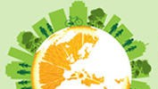


- Introductions – Class room introductions and review CCS website
- Syllabus Overview
- Lecture
- Break
- Video
- Debate (if time permits)

Obesity, Consequences and focus on the Hispanic Community

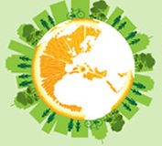
Archana J. McEligot, PhD CSU Fullerton
HESC 471

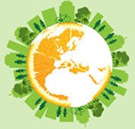
Objectives

- Define obesity
- Discuss obesity trends
- Outline consequences of obesity
- Discuss obesity and consequences in the Hispanic Population
- Structural factors that effect obesity

Define Obesity

What is Obesity and how is it measured?


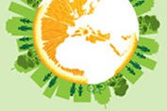



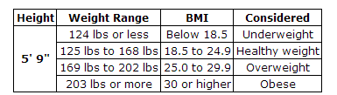
What is obesity?
  - Overweight and obesity are both labels given to ranges of weight that are considered unhealthy in relation to a persons height (CDC)
  - In the US, Body Mass Index (BMI) is used to measure obesity by kg/m2 (weight/ht2)
  - For adults, the following scale is used:

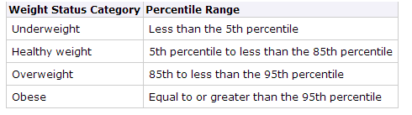
Measuring Obesity in Children
  - BMI is also used to measure obesity in children
  - However, because children are at various growth stages during childhood, percentiles are used
  - The percentile indicates the relative position of the child's BMI number among children of the same sex and age (CDC.gov)

Obesity Trends

What are the trends?

Consequences

What are the consequences of obesity?

What are the consequences of obesity/overweight?

Physical | Psychological | Economic
Cardiovascular Disease | Feelings of insecurity | Medical Burden – annual cost of $147 billion Work absenteeism Disability and unemployment benefit costs
Type 2 Diabetes | Bullying
Gall Bladder Disease | Social Stigma
Hypertension | Discrimination
Dyslipidemia | Lower Quality of Life
Osteoarthritis
Possibly Cancer

Obesity Trends Among U.S. Adults
Between 1985 and 2010
(DATA, text and MAPS are directly from CDC)
Source of the data:
- The data shown in these maps were collected through CDC’s Behavioral Risk Factor Surveillance System (BRFSS). Each year, state health departments use standard procedures to collect data through a series of telephone interviews with U.S. adults. Height and weight data are self-reported.
- Prevalence estimates generated for the maps may vary slightly from those generated for the states by BRFSS (http://aps.nccd.cdc.gov/brfss) as slightly different analytic methods are used.

Overview of Trends
  - In 1990, among states participating in the Behavioral Risk Factor Surveillance System, 10 states had a prevalence of obesity less than 10% and no state had prevalence equal to or greater than 15%.
  - By 2000, no state had a prevalence of obesity less than 10%, 23 states had a prevalence between 20–24%, and no state had prevalence equal to or greater than 25%.
  - In 2010, no state had a prevalence of obesity less than 20%. Thirty-six states had a prevalence equal to or greater than 25%; 12 of these states (Alabama, Arkansas, Kentucky, Louisiana, Michigan, Mississippi, Missouri, Oklahoma, South Carolina, Tennessee, Texas, and West Virginia) had a prevalence equal to or greater than 30%.

Citations
  - Mokdad AH, et al. The spread of the obesity epidemic in the United States, 1991–1998. JAMA 1999;282:16:1519–22.
  - Mokdad AH, et al. The continuing epidemics of obesity and diabetes in the United States. JAMA 2001;286:10:1519–22.
  - Mokdad AH, et al. Prevalence of obesity, diabetes, and obesity-related health risk factors, 2001. JAMA 2003;289:1:76–9.
  - CDC. State-specific prevalence of obesity among adults — United States, 2005. MMWR 2006;55(36):985–8.
  - CDC. State-specific prevalence of obesity among adults — United States, 2007. MMWR 2008;57(28):765–8.
  - CDC. Vital signs: State-specific prevalence of obesity among adults — United States, 2009. MMWR 2010;59:1–5.

BRFSS, 1990, 2000, 2010
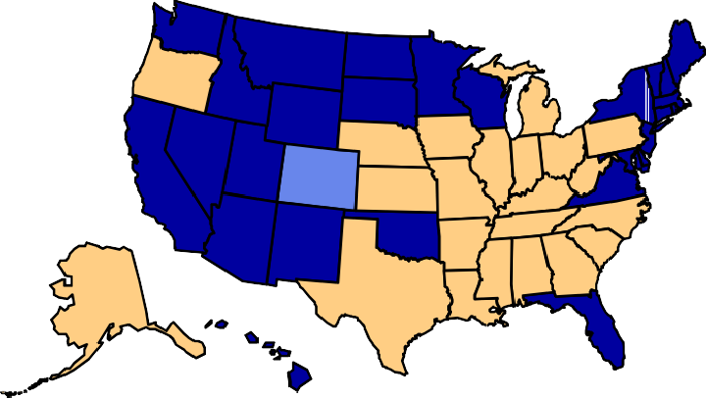
(*BMI ≥30, or about 30 lbs. overweight for 5’4” person)
2000
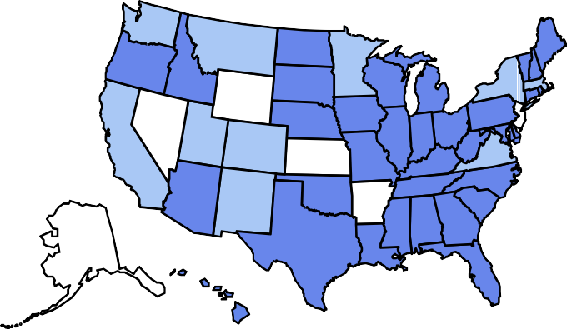

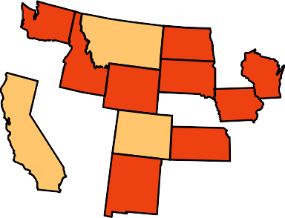

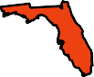
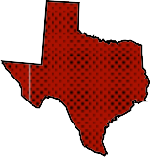

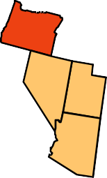
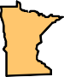




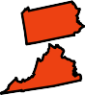

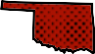
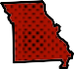
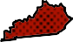


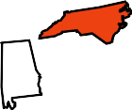

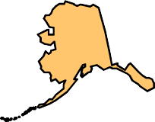
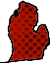



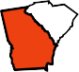
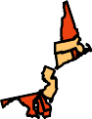

1990
2010





No Data
<10%
10%–14%
15%–19%
20%–24%
25%–29%
≥30%

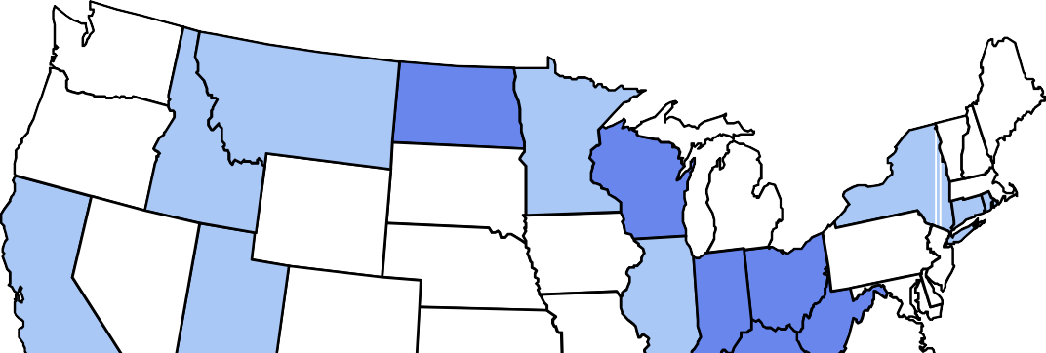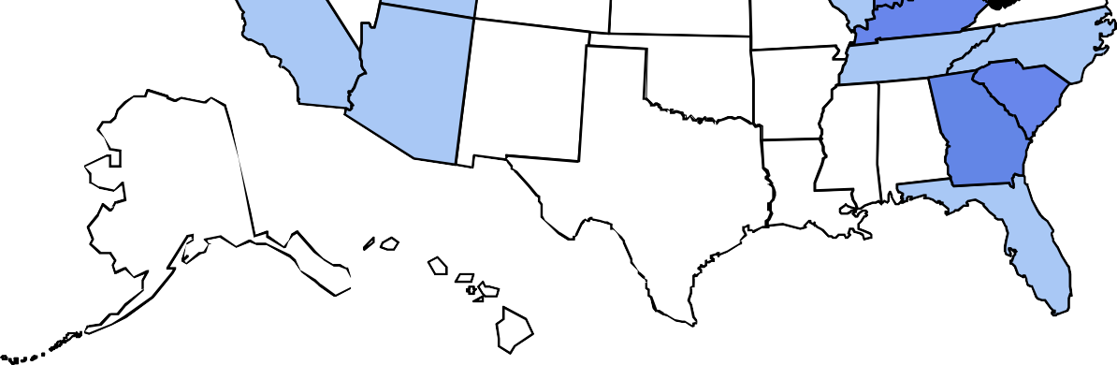

No Data <10% 10%–14%

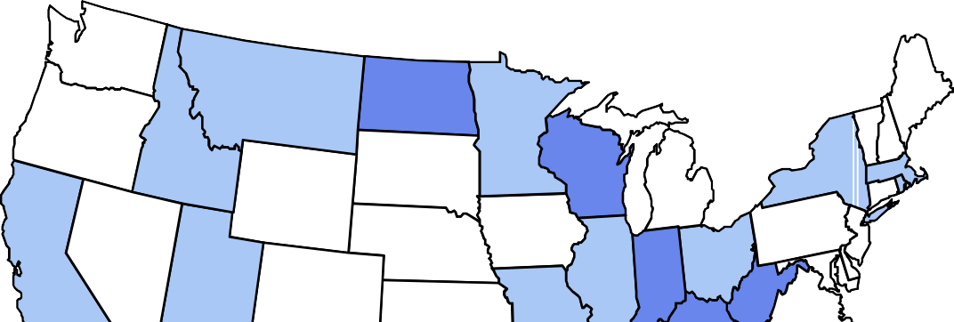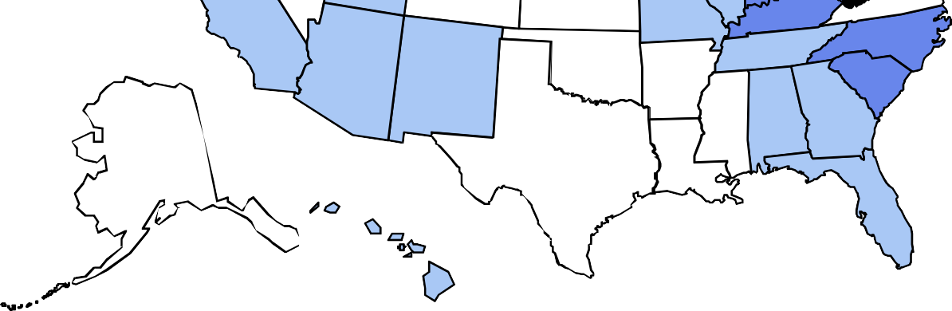

No Data <10% 10%–14%

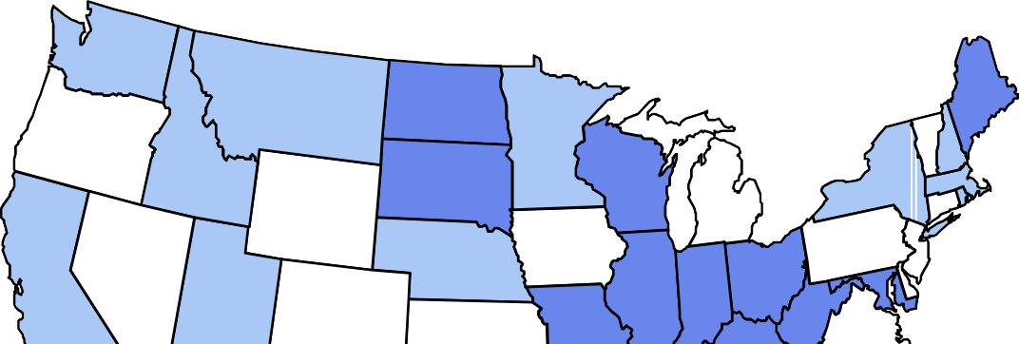
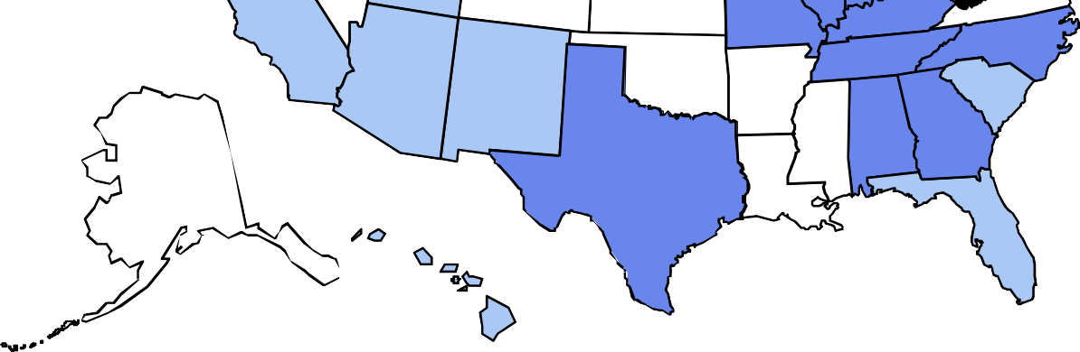
(*BMI ≥30, or ~ 30 lbs. overweight for 5’ 4” person)

No Data <10% 10%–14%

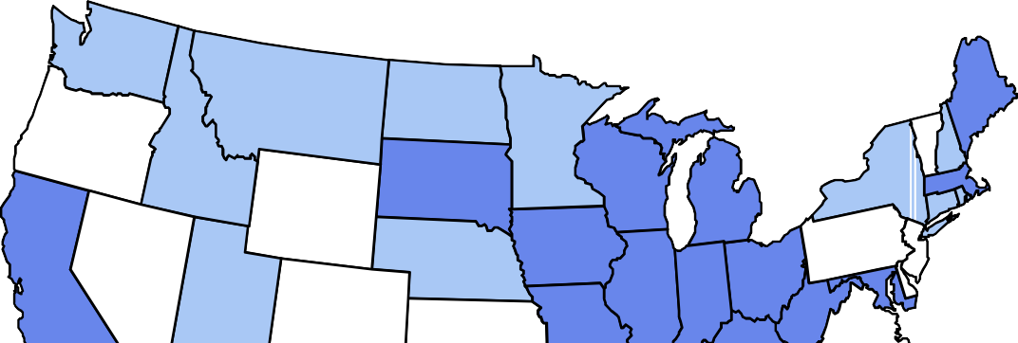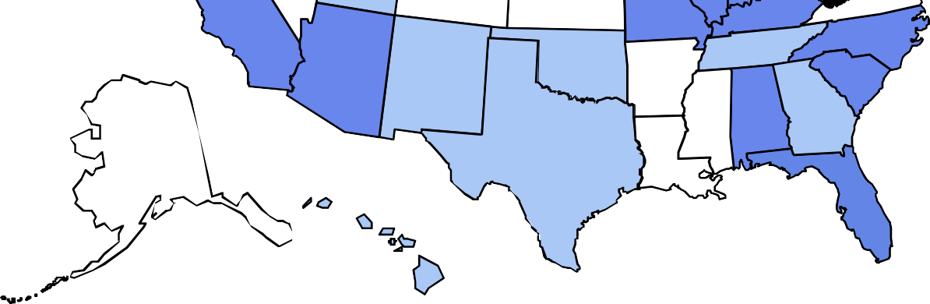

No Data <10% 10%–14%

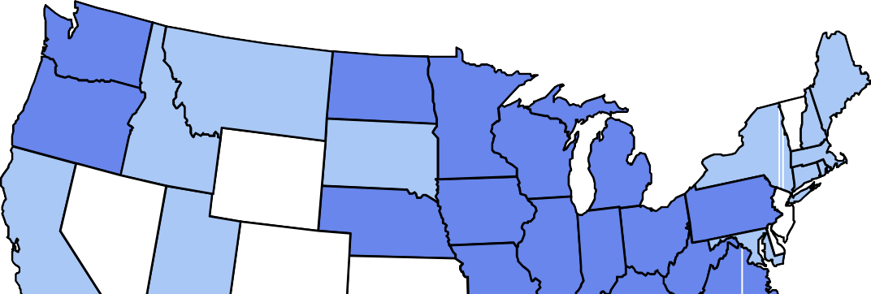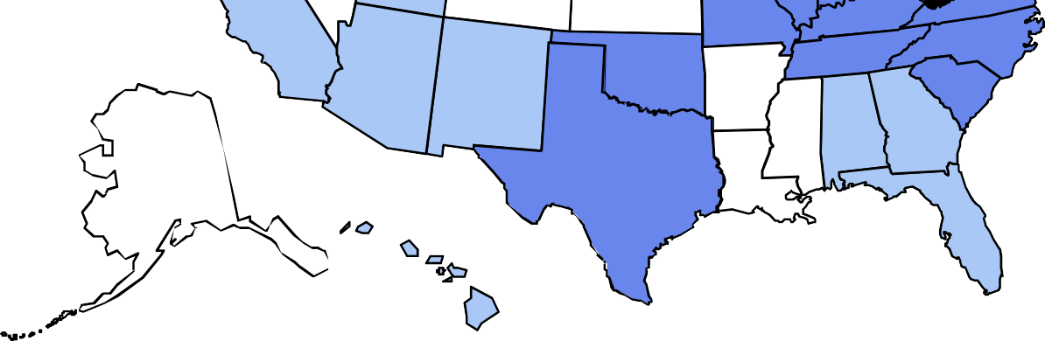

No Data <10% 10%–14%

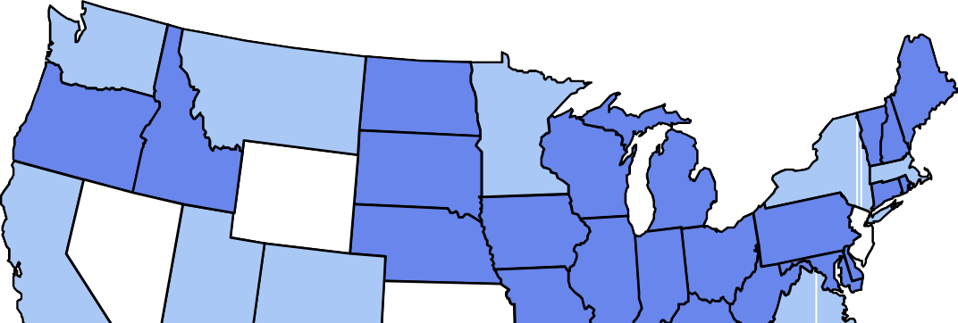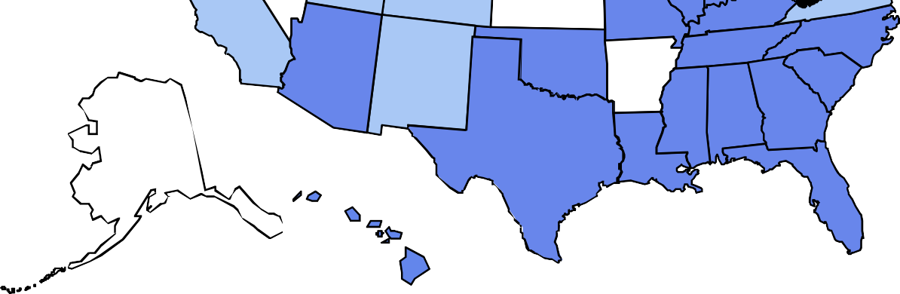

No Data <10% 10%–14%

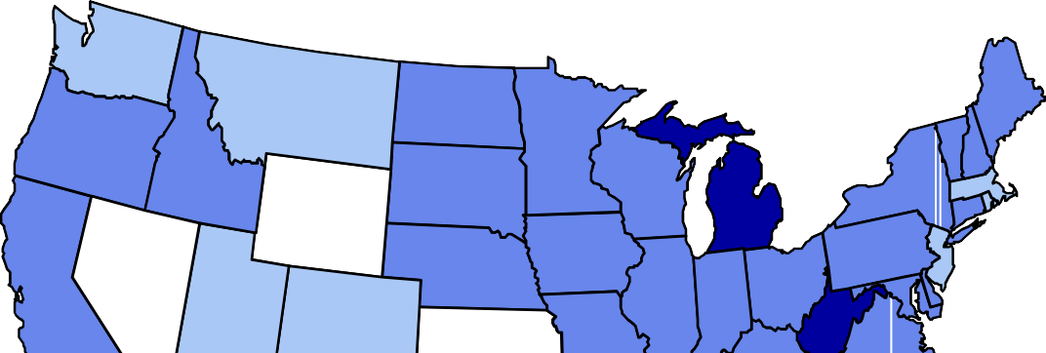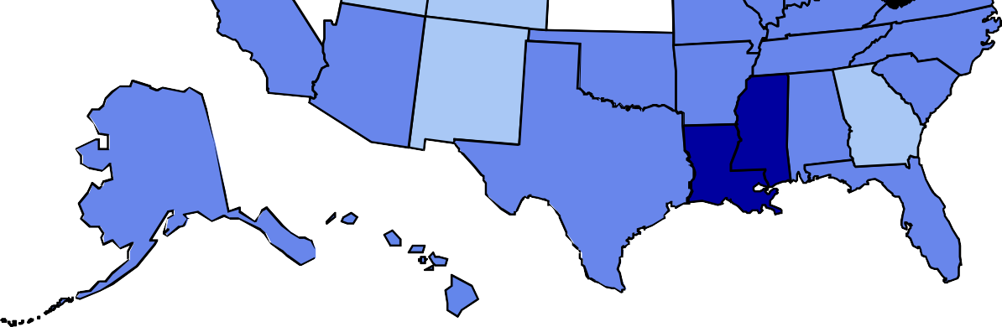

No Data <10% 10%–14% 15%–19%

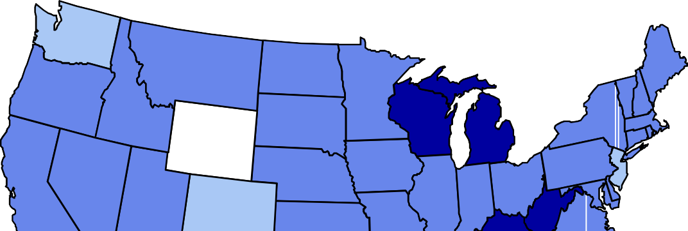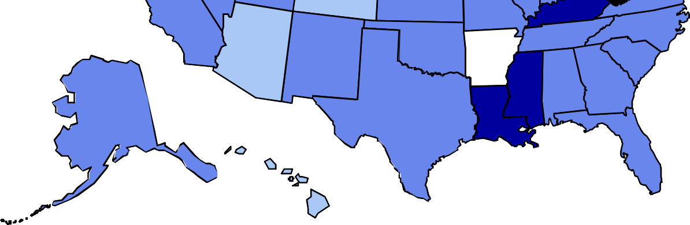

No Data <10% 10%–14% 15%–19%

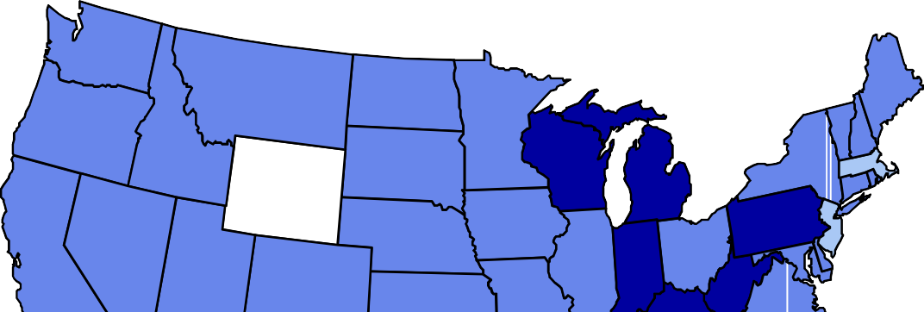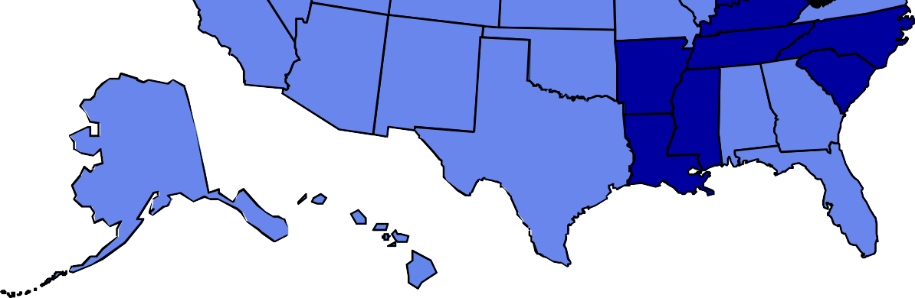

No Data <10% 10%–14% 15%–19%

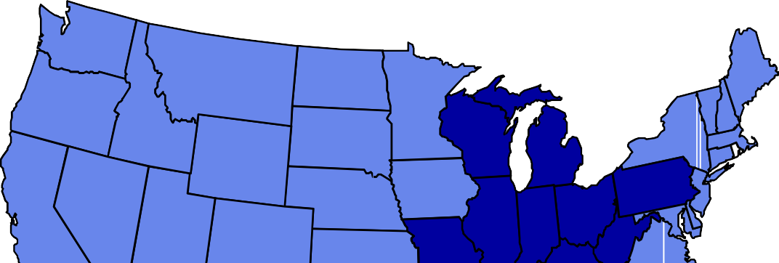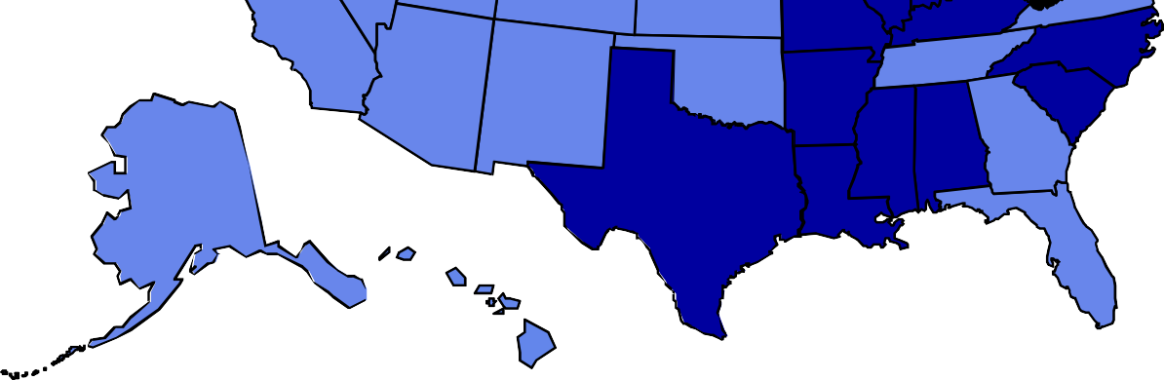

No Data <10% 10%–14% 15%–19%

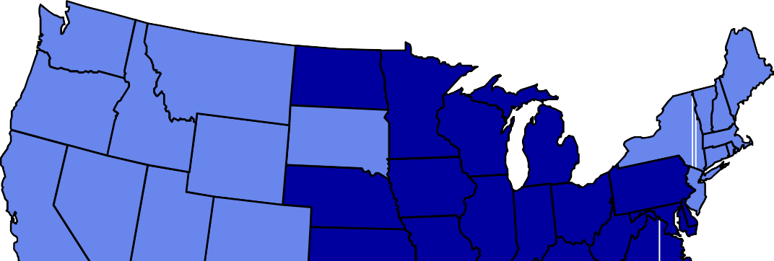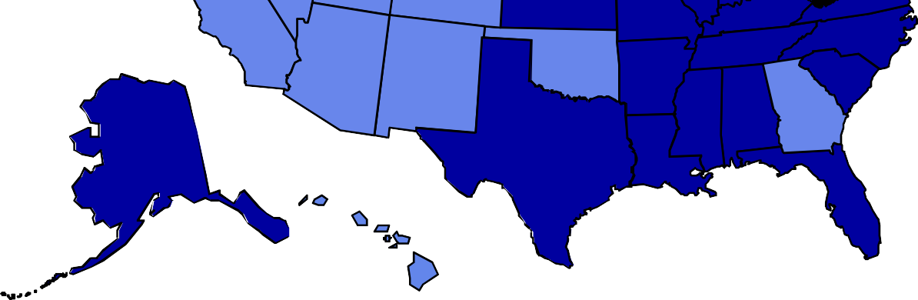

No Data <10% 10%–14% 15%–19%

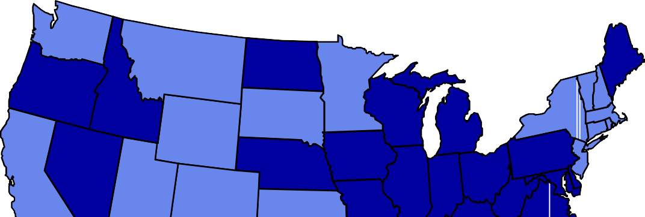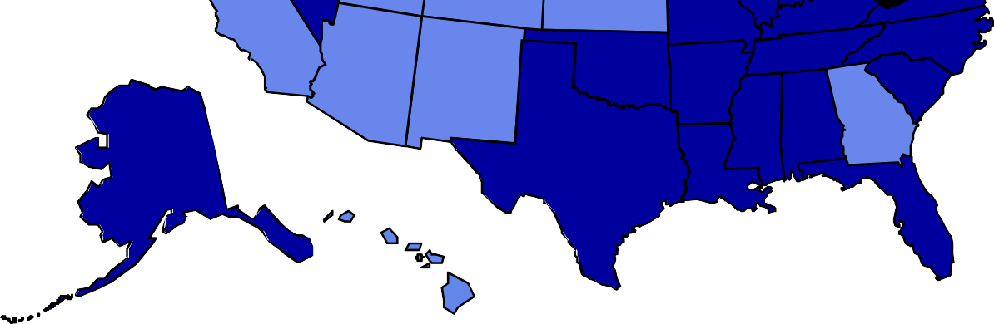

No Data <10% 10%–14% 15%–19%

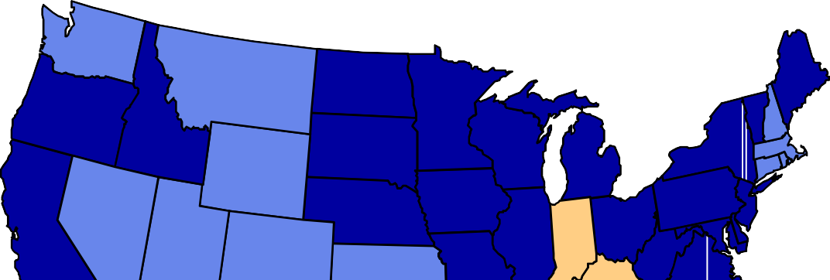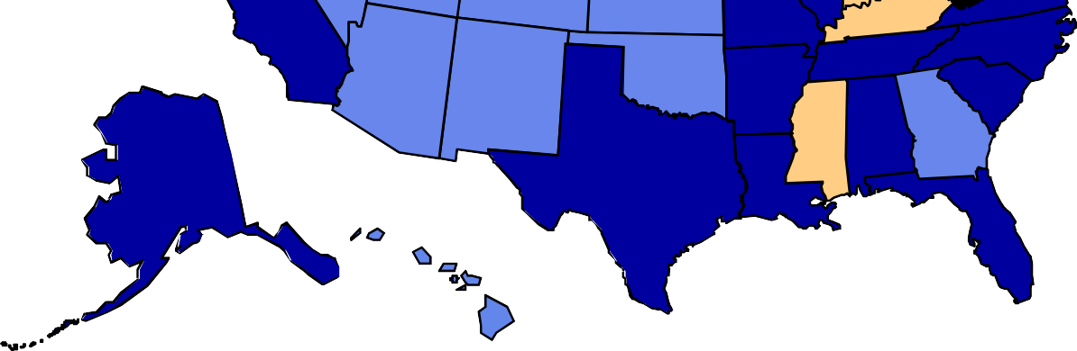

No Data <10% 10%–14% 15%–19% ≥20%

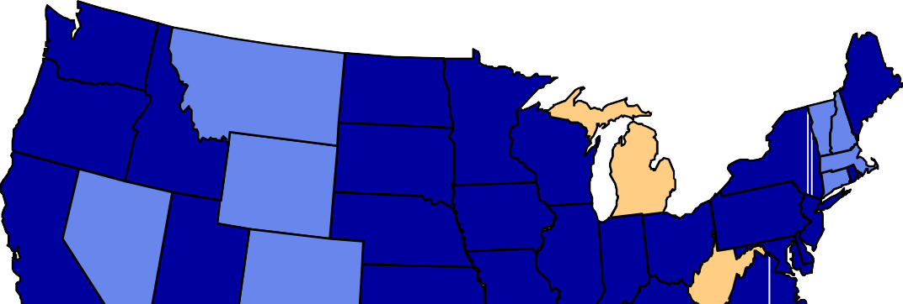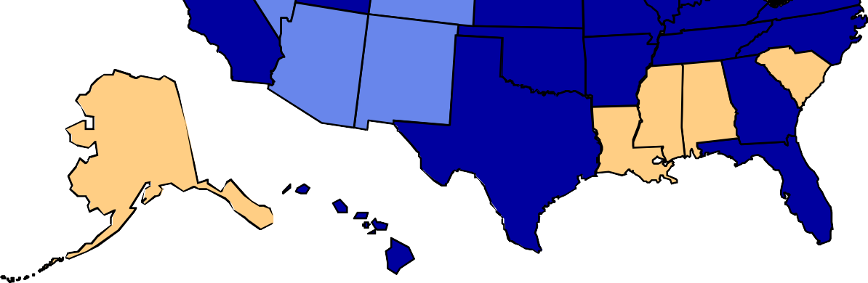

No Data <10% 10%–14% 15%–19% ≥20%

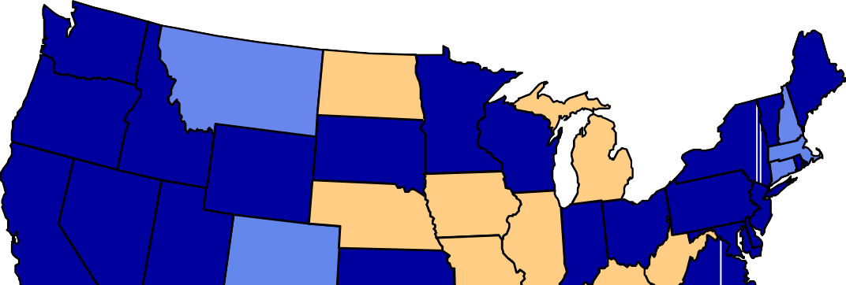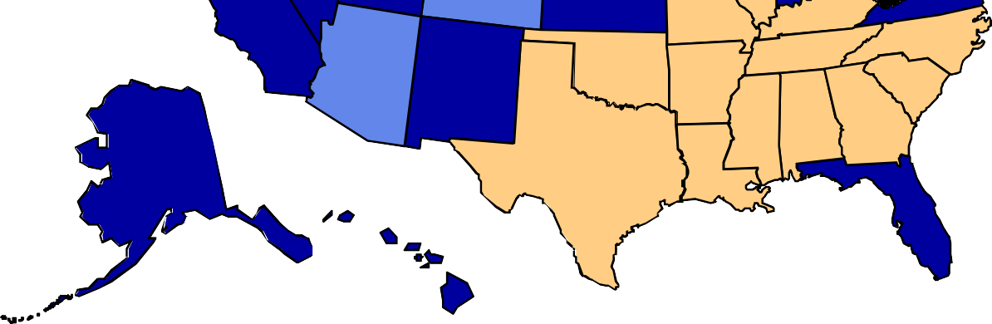

No Data <10% 10%–14% 15%–19% ≥20%

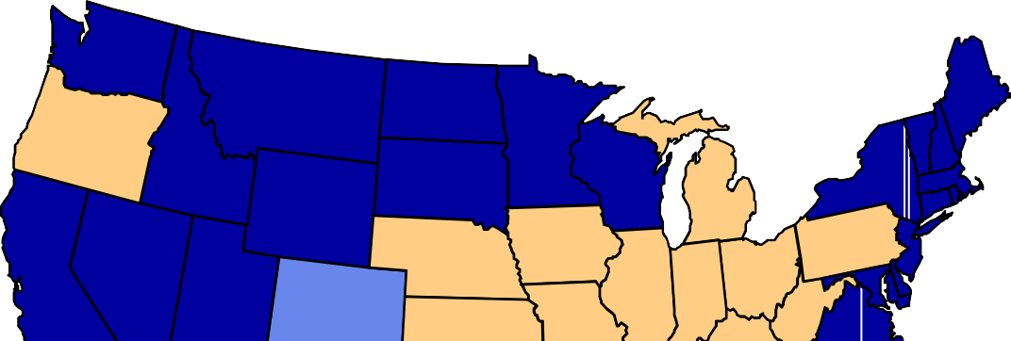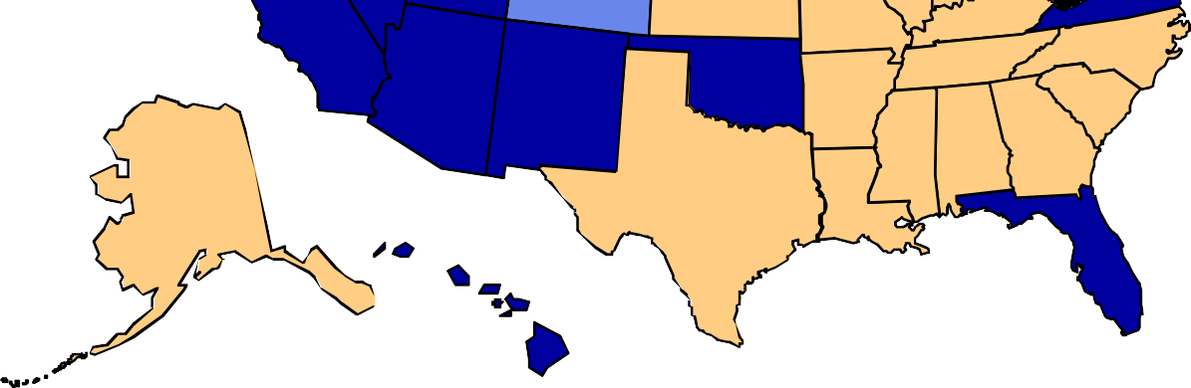

No Data <10% 10%–14% 15%–19% ≥20%

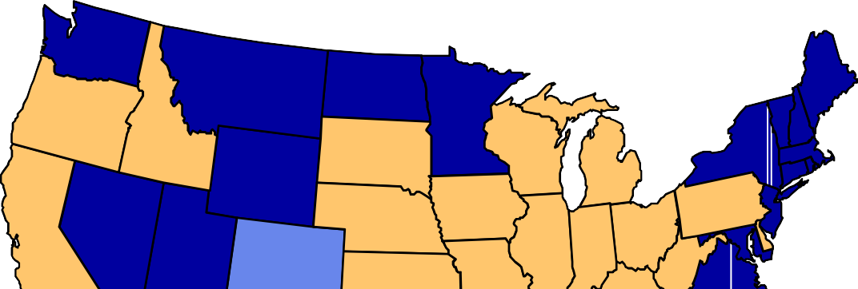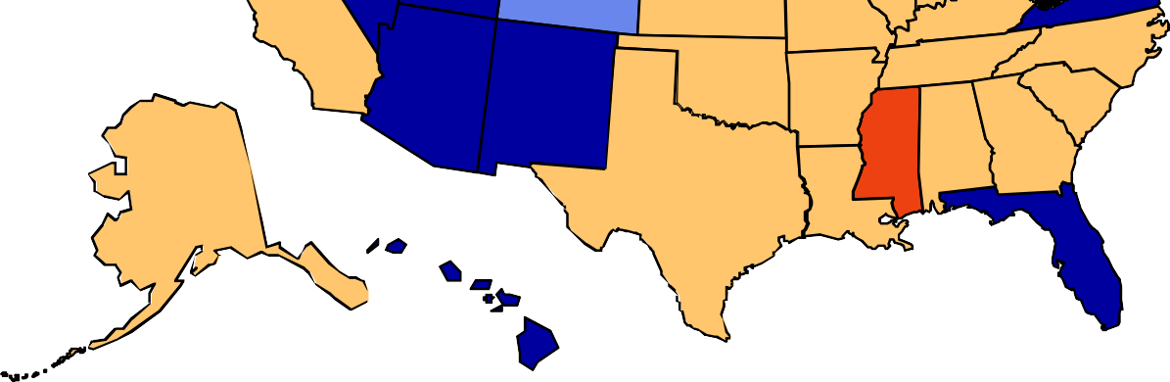

No Data <10% 10%–14% 15%–19% 20%–24% ≥25%

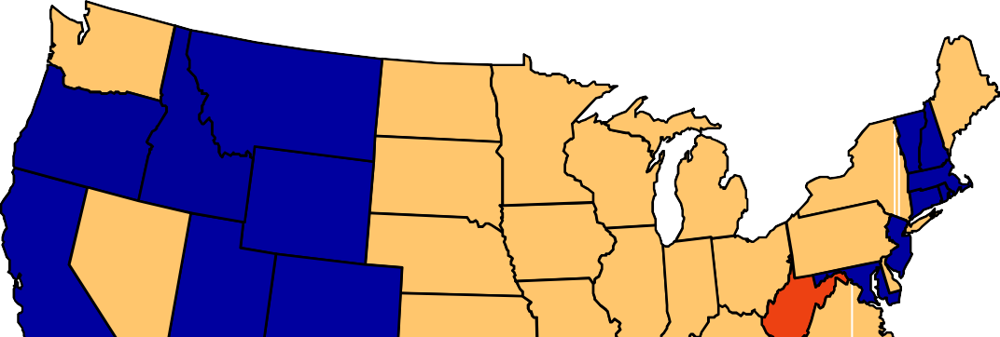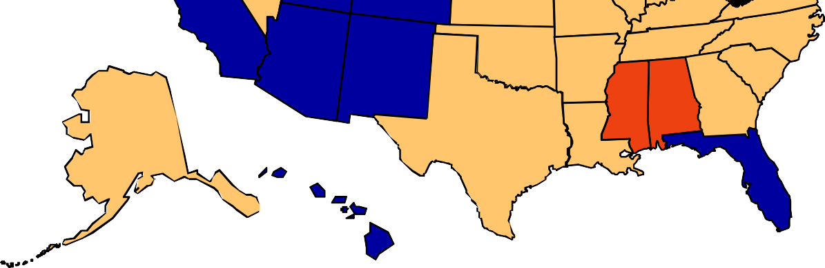

No Data <10% 10%–14% 15%–19% 20%–24% ≥25%

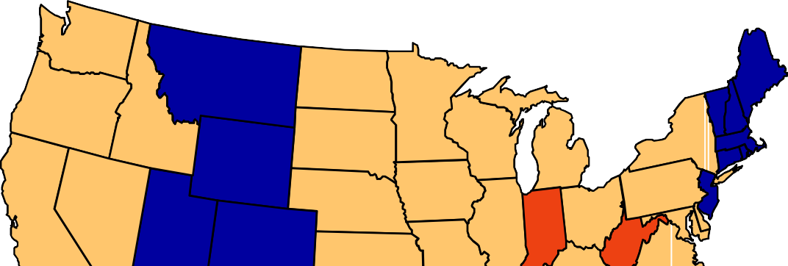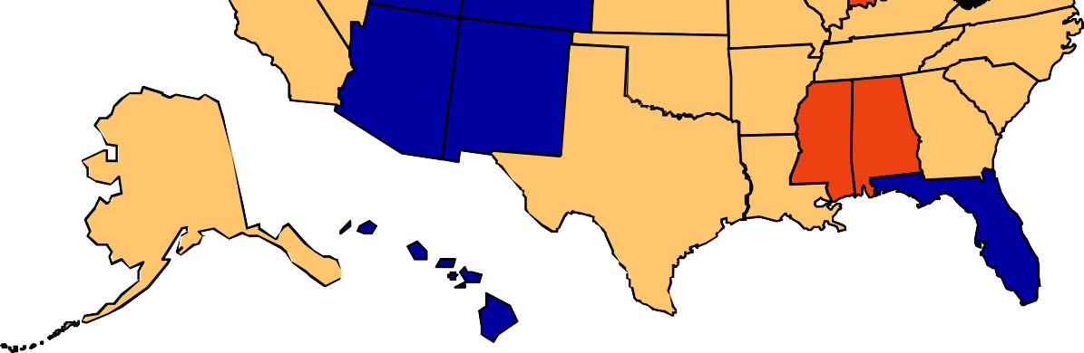

No Data <10% 10%–14% 15%–19% 20%–24% ≥25%

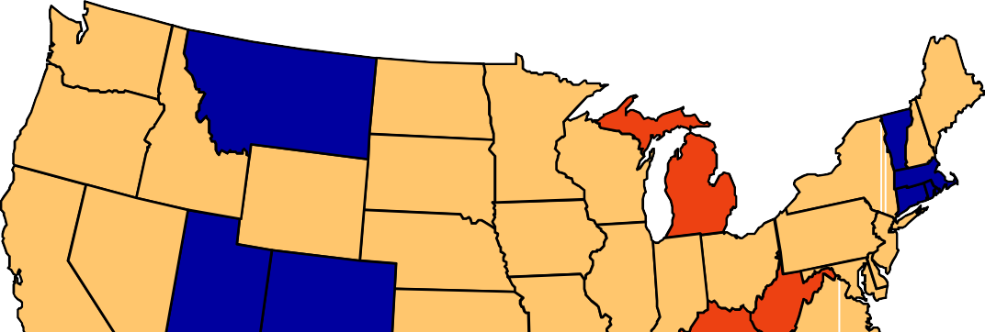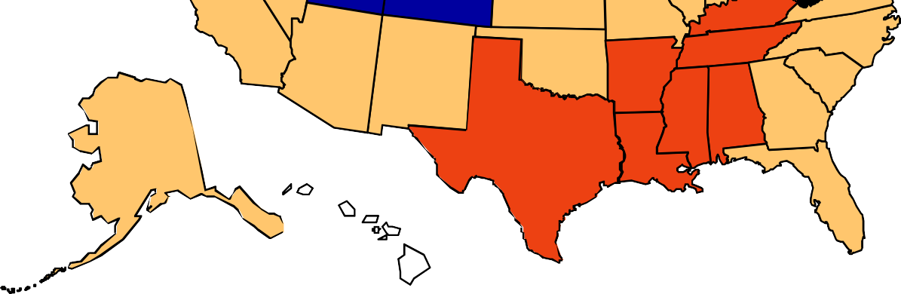

No Data <10% 10%–14% 15%–19% 20%–24% ≥25%

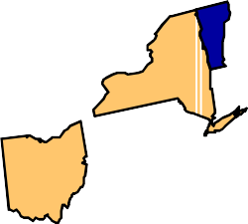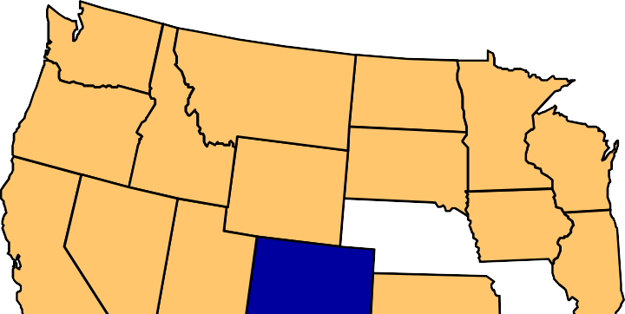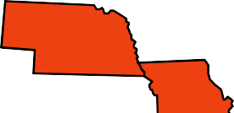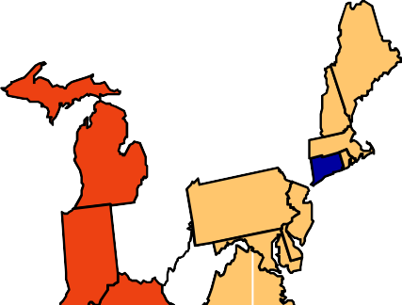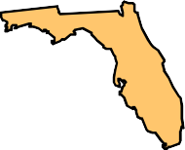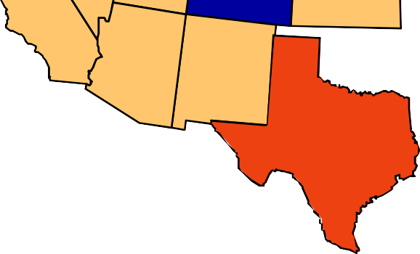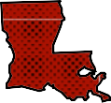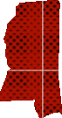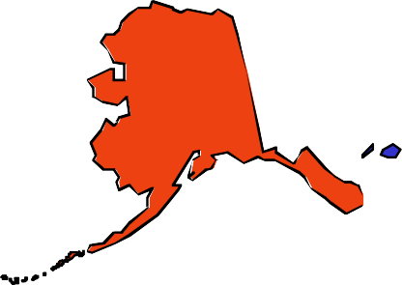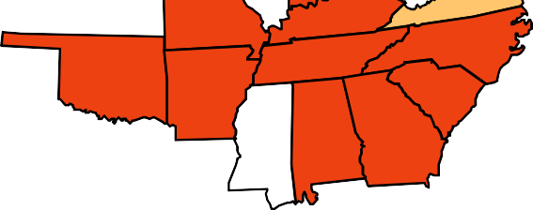

No Data <10% 10%–14% 15%–19% 20%–24% 25%–29% ≥30%

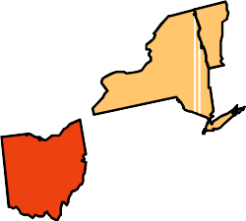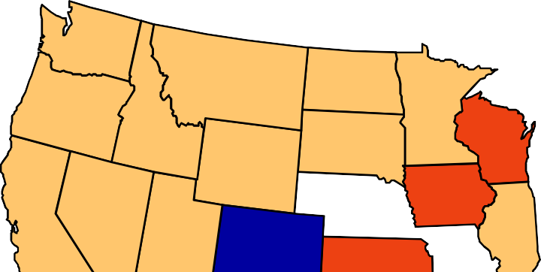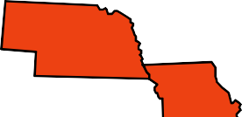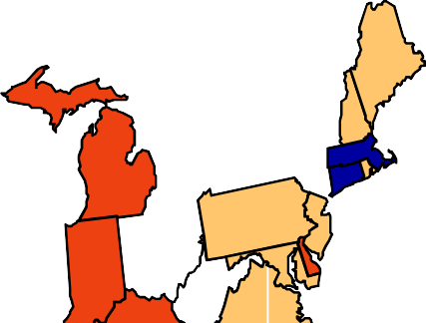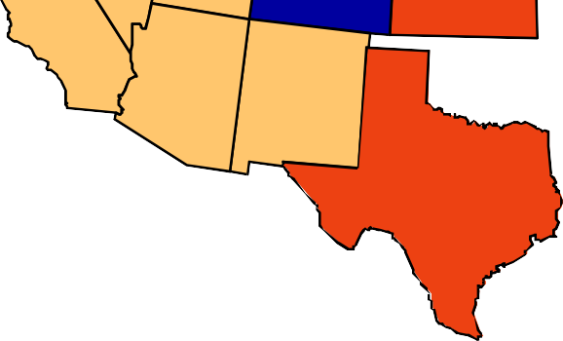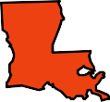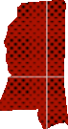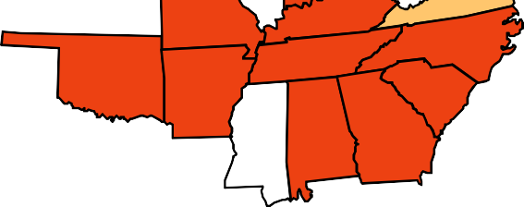

No Data <10% 10%–14% 15%–19% 20%–24% 25%–29% ≥30%

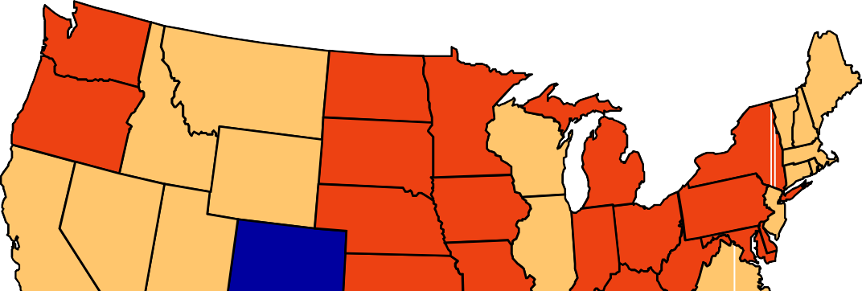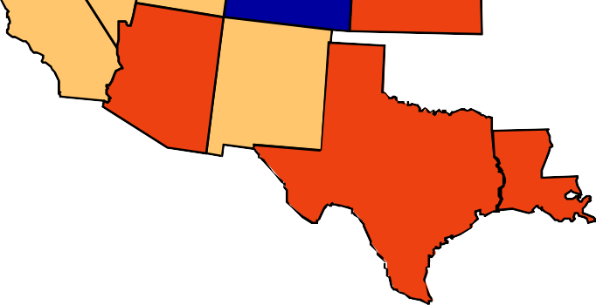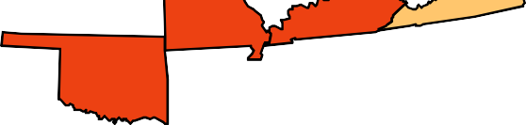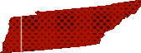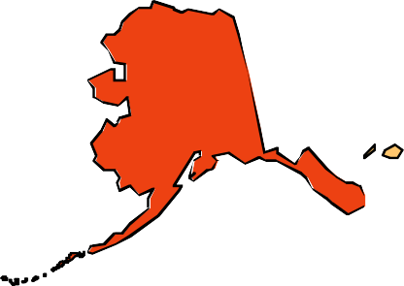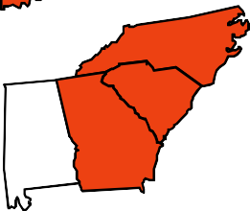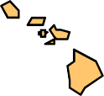

No Data <10% 10%–14% 15%–19% 20%–24% 25%–29% ≥30%

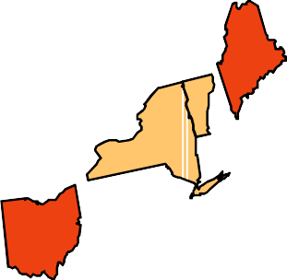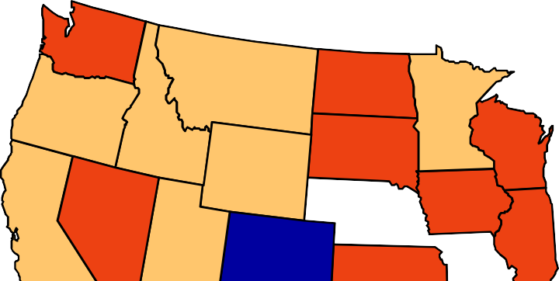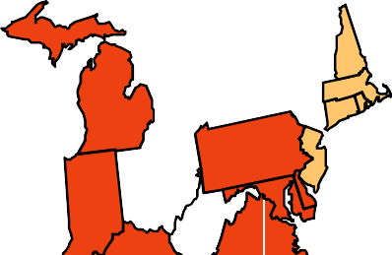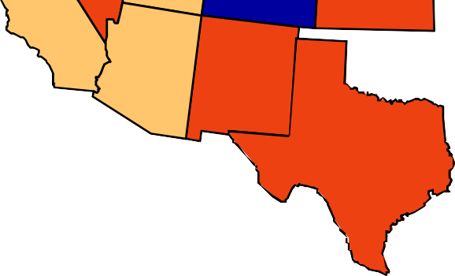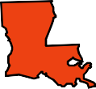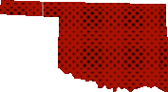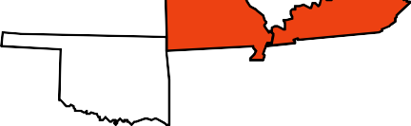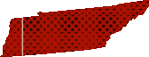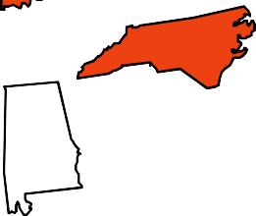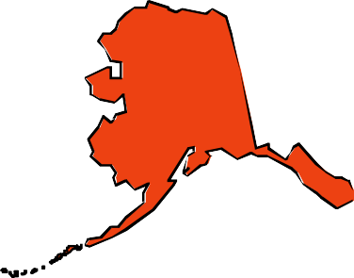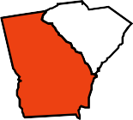

No Data <10% 10%–14% 15%–19% 20%–24% 25%–29% ≥30%

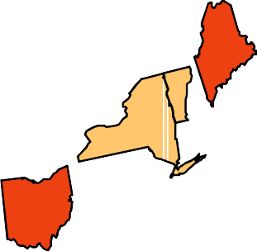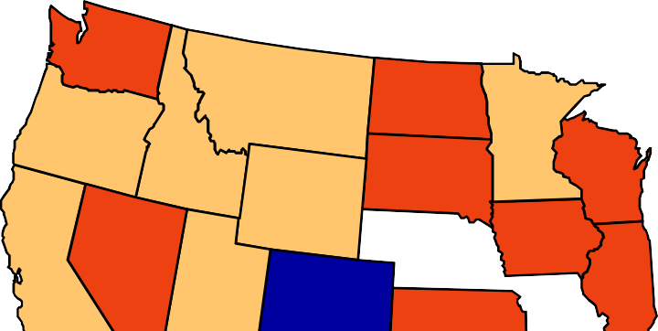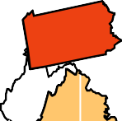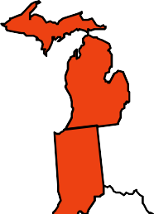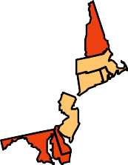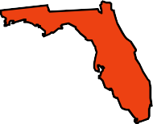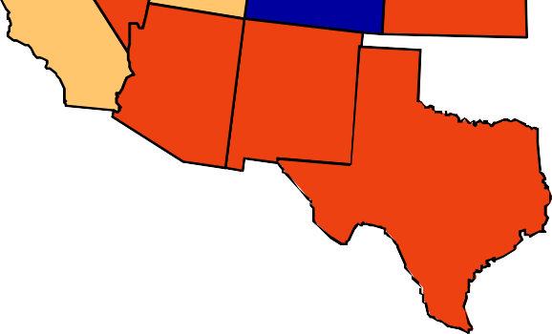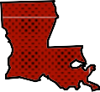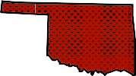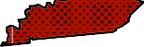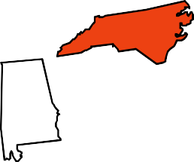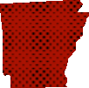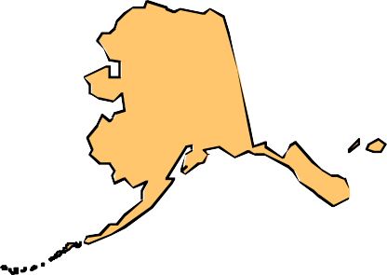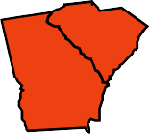

No Data <10% 10%–14% 15%–19% 20%–24% 25%–29% ≥30%

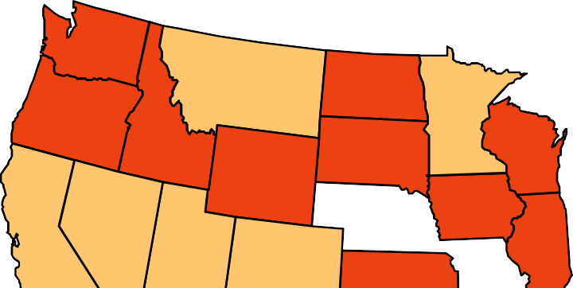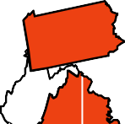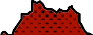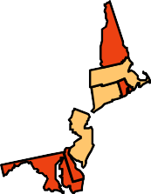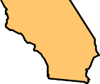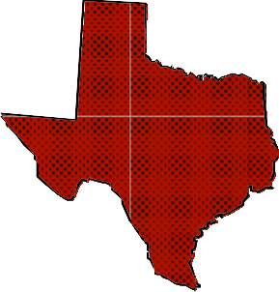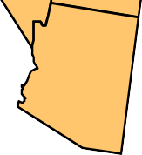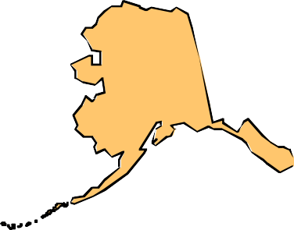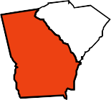

No Data <10% 10%–14% 15%–19% 20%–24% 25%–29% ≥30%

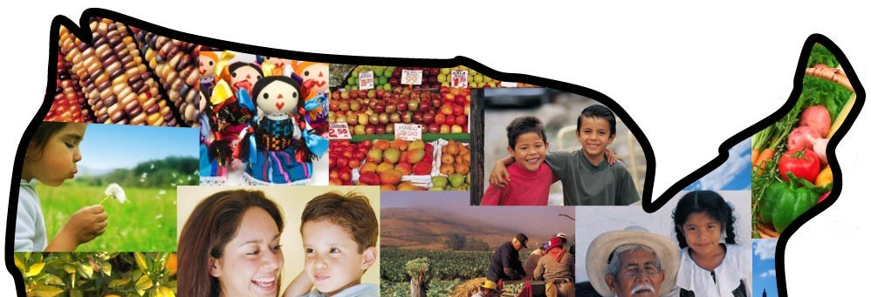
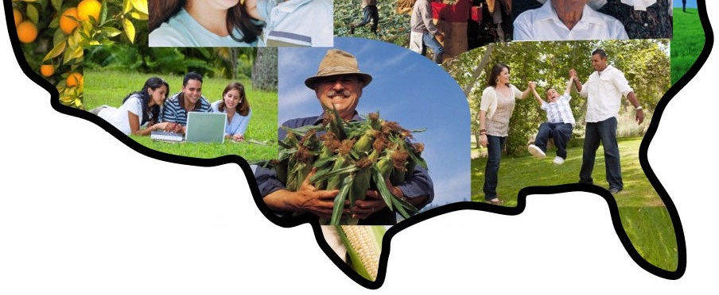
Hispanic and Latino Americans

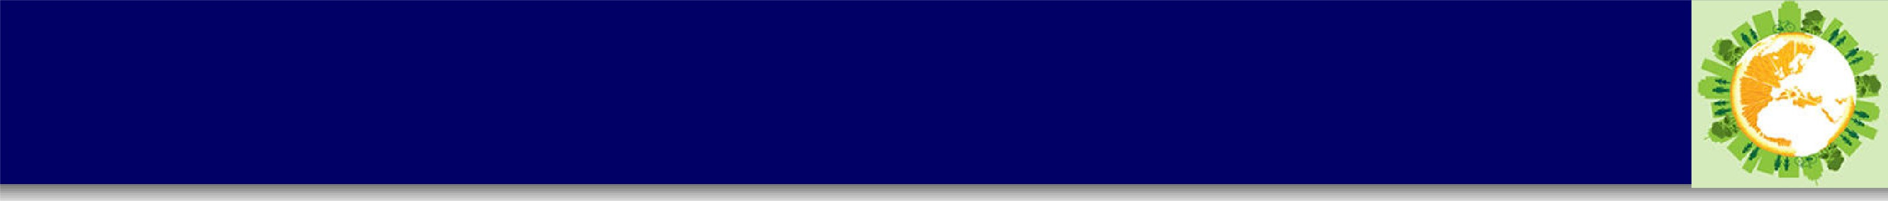
Overweight in Hispanic Americans

., Among MeXJican American women, 78 percent a:re nvermxeight or obese, as compa:re,d to only 6,0_3 percent ofb.he non-Hispanic White women.
., In 20·10, Hispanic Americans we'Fe 1.2 bmes as likely to be obese tihan Non-Hispanic Whites.
., In 200,9_20'10 MeYJican American children were ·1_6,bmes mo'fe likely to be o,ve'vweig'ht as Non- Hispanic White Children_
- From 2007-2010, MeYJican American women were 410% more Iikely to be oveT1neight, as c ompa:re,d to Non-Hispanic Whites_
Ag,e,-.adjusied pe,roe,r,t_ag,e,o,f o,v1e,rwe,igtd pe,rsons 201 y1e1ars o,f ag,e,,and ovie·r who,ar1e•o,be,se·, 2.00,7·_
,2,Qi1CJi(.P1e,rsons ,are·conside·re-dolle·se·ifth,e,y have·a Body Mass lnde·,x (B . I) of JDor gre·ate·r.)
NationaI He1alth ,ar,d Nutritio,n E:itaminatior, Surv1e,y (NHANES)1

I | Me,:rdcan Ame,rican | I | Non-Hisp1anic White, | I | Me•J<Jcan Ame•ricanJ Ncm-Hispiani c Whit,e,
Men  Women | 36_3  44.6, | 34,_·1  32.5 |  | 1 _'1  1.4

S-01J1rce: CDC 2012. Healb.h Unite,d S-tates, 20'11. Table 74. http:l/www_cdc_g·ov/nchsldatalh1J1s/h1J1s11.pdf uPDF I 9i_8MB,]

P1e,roe·ntag,e·o,v1e•rwie,ight ,among childr1e•n ,and adol,e·soents 6-11 years o,f ,ag,e·,.2.001·-.2.a,1a

I | Mex.ican American | I | Non-His1Jianic White· | I | Me·xican Ame·rican/ Non-Hisp1anic Whit,e·Ratio
Girls | 2:2_4, | 14.0 |  | '1.6
Bo,ys | 24-.3 | 18.6 |  | '1.3
S-0L1rce: OOC.2:012:. HealtJh Unite.d States, 2:011. Tab1e 75.
http:!/w,row_cdc.gwr/11chsldatalhL1slhL1s11.pdPf DF I 9'_8MB]

P1e,roe,ntag,e,o,f childr1e,n and ie,e,ns ,ag,e,s ,2:-1191 who we,r,e,told by a doctor that th,e,y wje,1ne,
o,v1e,rwe,ight, ,2,ll015 -2,0018,

rtl'lexican American I | Non-Hispanic White | I rtl'le,xican Ame,rican! Non-Hispanic Whit,e,Ratio,
4J_6, | 38.5 | 1.1
S0U1rce: 20·1·1 r'\Jabional Healthcare Disp.aribies Report. Tallie 6_4_4.'1 http:llMm.ahrq.g'o1t/qLaIIll qrdr11li11,dex.html
fJ1e·roent o,f childlie,n ,ag,e ,2:-17 fo,r whom a docto,r or other h,e1alth p1rovid,e,i1re,\f\e,r gaV\e,,advice ,about
,amount and kind of p1hysical activity, Uniied Staie,s, ,2,0018,
·1.'1
32.2
36,.3
Hisp1anid Non-Hisp1anic White,
I
Non-Hisp1anic Whit,e,
Hisp,anics I
S-0U1rce: 201'1 r'\Jat1io11a.lHealthcare OU1a.lity Repo'Ft. Tab:le 9'_'1_8.2b http:ll i"!NW'.ahrq.g·o1t/qLaIIllgrdr11li11,dex.html
fJ1eroent o,f childlie,n ,ag,e,,2:-17 fo,r whom a doctor or other h,e1alth p1rovid,e,r e,\f\e,r gaV\e,,advice,,abo,ut reating h,e1althy, United State,s, ,2,008

Hisp,anics I | Non-Hispanic Whit,e• I | Hisp1anid Non-Hisp1anic White•
49'.7 | 49.0 | '1.0
S-olJlrce: 201'1 Nabiona.lHealthcare OU1a.lity Repo'Ft. Ta.Ille 9'_'1_9i.2b http:ll'W!lll'_1aihl.rlq' .901t/qLaI ll qrdrO9i/i11,dex.html

What factors influence obesity?

Ecological Model/ Social Context
- Ecological model (Sallis et al., 2006)
- Social Contextual Theory
- Review figure 2 – 1; Both the macro and microenvironments influence weight, physical
activity and eating behaviors

Policy and Physical Activity
- Zoning, building codes, transportation and recreational design effect the built environment
- Policies effect programs, such as PE requirements in schools and sports programs and leagues in parks and recreation centers
- Incentives for insurance discounts, parking discounts or commuting by bikes
- Funding for policies and programs is critical

The built environment, policy and policy makers
- There is a relationship between weight (obesity/overweight), physical activity, nutrition and policy
- The following figure demonstrates how the built environment and/or elements in the built environment that effect physical activity can be shaped by policy, and the decision makers who implement those policies

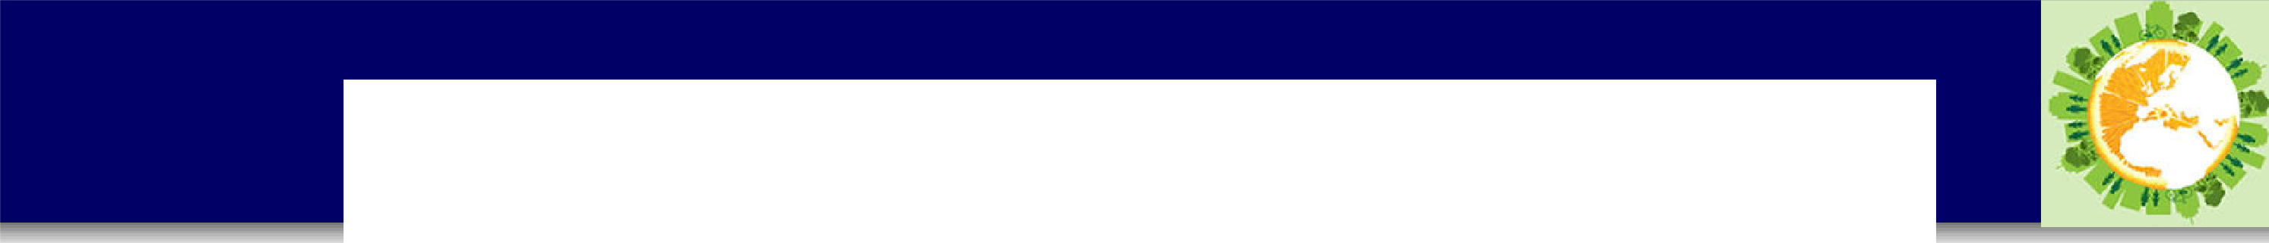
TAULE 1-1. Rd.at1onship:sAmong Sdected Influences on Pllysical Acttvky
Environment Attri.bl!lte
Policy Detem1inant
Decis!iori 1\.-hkers

l'd.ixed land use

Street oon·nectivity

Re.stdential d.e·nsity

Pedesrrianlbrcyde faciluties:

Traffic volumel:speed

Transit acoess

Parks, trnils

Pirivalie riecr-eation facili.tie.s Ae.sd1et:ics1 v etation School grounds, siting
Zoning

Gllli.delin.est standards

Zoning

Transpowtomp1.ete streets*

Transport

Transport

Park and [iec:rearim1 standards and funding
Marikiet_phce Various
Standards, joint-1!1.se agreements
Loca I gov,ernments {as
informed b_yplanning officials)

l:nstitute of Transportation Engineers; dei."eloper oca I governme'l!'t1ts

Loca I gov,ernments {as informed b_yplanning officials)
Transponati.on departrne,nts; state and oca I gov,emments

Trans_portati.o:n de_partme,nts; governme·nits

Trans_ponati.o:n de_partrne,nts; governme'limrs
Develope.rs of national standards; local gD\'ern men rs

Busfo.ess owners M1!1.lt:i.pfe
Sta lie edocarion d.epa rtm.ents and gmremments

*A cmnplete sttieet i.sa mad designed a-11d operated to be safe for alI users, indudi"11g dri.vers1 hicydis transit v,ehides and us.erst a11d pede.stri.ans of aU ages and abilities.
S:OllRcCE Sa Hi.s, 2011..

Building Bridges
- The following needs to be considered in order to improve obesity, physical activity and nutrition through policy:
  - Appropriate measurement is needed for the policy and the environment, both the presence and quality of each
  - Cross-collaboration between public health sectors and non-health sectors
- Provide examples of above

Appropriate Measurement
- How are policy data measured?
- What are the appropriate tools and how to improve them?
  - Surveys
  - Observations
  - Geographic Information Systems (GIS)
  - Policy Measures
  - Crime Measures

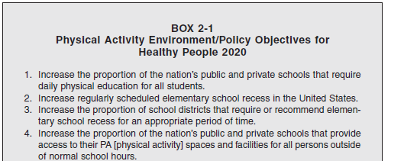
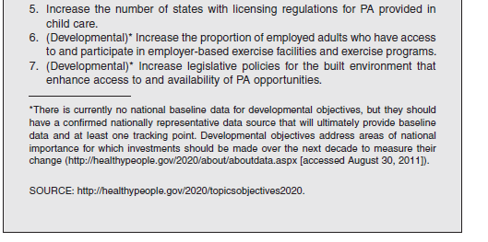
Healthy People 2020 Physical Activity and Policy

Healthy People 2020 Nutrition and Policy
Nlutritiion and Weiight Status

Numbeir Objjective Short Title
Healthier F'oodl Access

NIWS-1 NIWS-2 NIWS-3
State nutrit1ion standards for clhil,d care
Nutriitious foods and beverages offered outsiide of school 1meals State-levell incentive policiies for food retaill

NIWS...-4 Retaill access to foods recoimmiended by Diietary Guidelines101r A1merica111s
Health Care and Worksite Settings.
NIWS-5 Prii1mary car1e plhysiicians who m1easure patiients' body 1mass iindex (BMI)

NIWS-6 NIWS-7
Physiciian offlice visiits w1ith nubiition or weiglht oounselling or education Worksite nutrition or weiig1ht m1anag1e1ment dasses or oounseliing

