
Lecture Overview

- Discuss SLI, internships and questionnaire completion
- BMI issues

- Food Environment
- Video
- Break
- Measurement

Obesity, Food Environments and Policy

Archana J. McEligot, PhD CSU Fullerton
HESC 471

Objectives

- Discuss issues with BMI
- Define food environment and food choices
- Discuss inequity and food environments
- Identify federal policies and programs
- Review measurement and surveillance of Nutrition/Food environments
  - Individual
  - Community

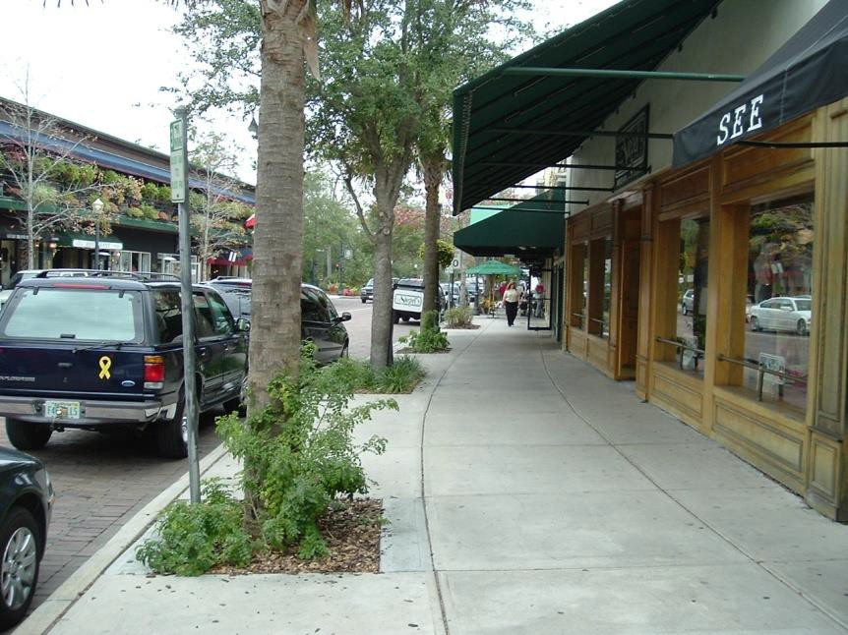
Built Environment
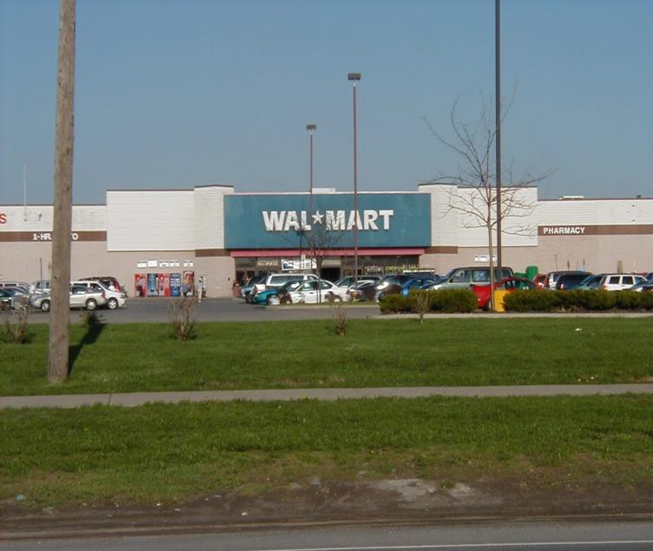
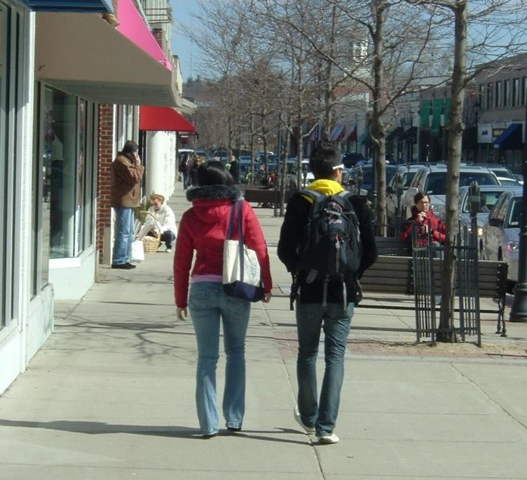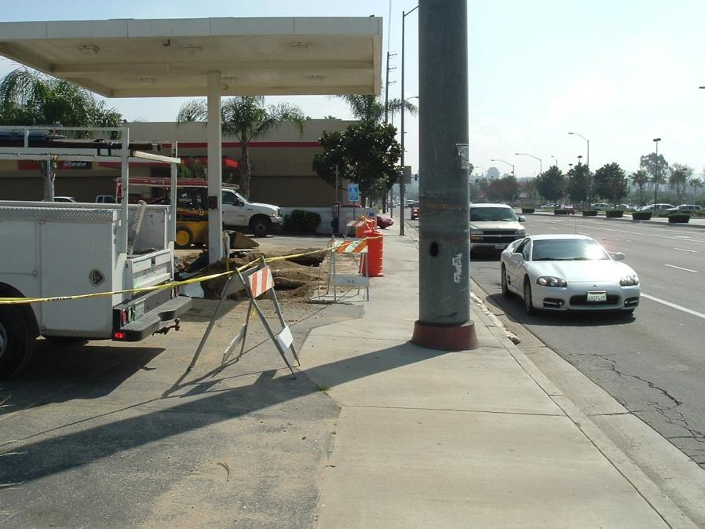


Built Environment
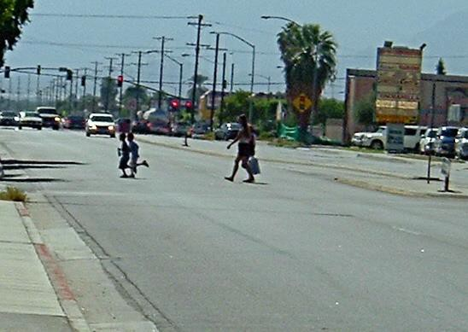
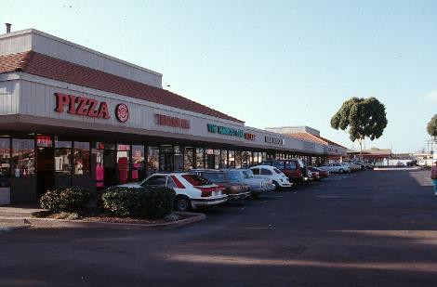
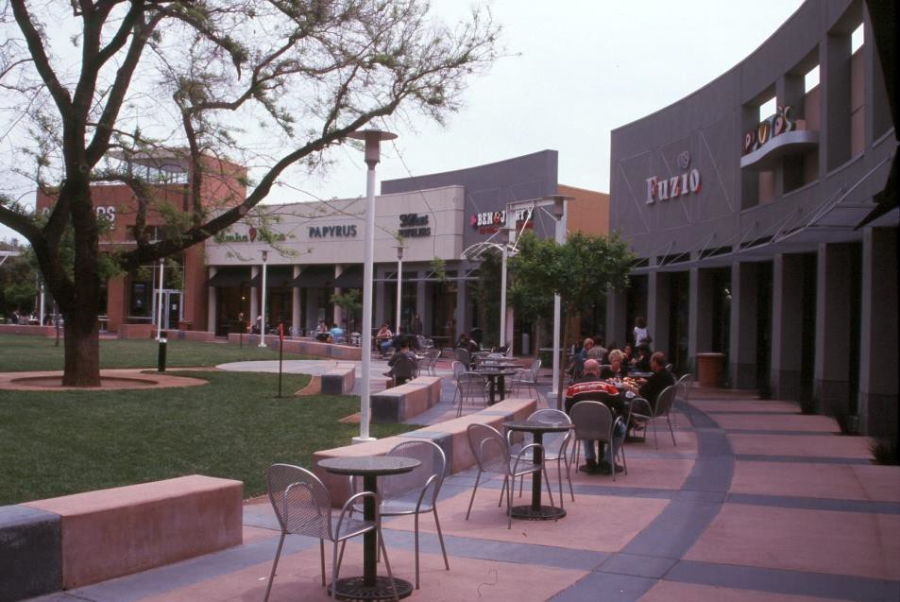

BMI issues

What are specific issues with BMI?


BMI issues
- BMI does not discriminate between lean or fat tissues
- In youth BMI is correlated with fat free mass (lean mass) and fat mass
- Height decreases with age, especially in women so this may effect overall BMI trends with age
- Body composition varies by ethnic group – Asians are a good example of why BMI in these groups may not be the best indicator of health
- Other considerations…waist circumference or waist to height ratio

Food and Nutrition Environment

Define and provide examples of the food and nutrition environment?

Food Environment
- Food Environment: Access to and availability of healthy and/or unhealthy food venues (supermarkets, grocery stores, ready made food) in a neighborhood, city or area.
- A food desert is a neighborhood or area with little or no access to large grocery stores that offer fresh and affordable foods needed to maintain a healthy diet. Instead of such stores, these neighborhoods often contain many fast food restaurants and convenience stores.

Community and Consumer Food
Environments
- Community Environments (the types and locations of restaurants, and supermarkets and the accessibility of these)
- Consumer Environment (what consumers encounter when purchasing foods – nutrition information, pricing and product placement)

Food and Nutrition Environment

What effects the food choices?

What effects food choices?
Review Figure 3-1 in Workshop Report

Weight of the Nation

http://theweightofthenation.hbo.com/films/main- films/Choices#/watch/main-films/Challenges

Chapter: disparities

Food Equity and Food Environment
- Let’s hear from you:
  - 1. What are your thoughts on food equity and food environments?
  - 2. What are the barriers to healthful eating and exercise in underserved communities?
  - 3. What can be done to improve eating behaviors, and increase physical activity in underserved neighborhoods and for children specifically?

Policy and Nutrition Programs

What types of nutrition programs can be influenced by policy and may effect nutrition environments?

Policy and Food Environments
- Various avenues to influence policy and food environment, but it’s complicated
  - An important step is to WORK with the COMMUNITY or neighborhood
  - Contact Public Schools
  - Food Assistance Programs
  - Price Support for Agricultural Products
  - Let’s Move Campaign – Rethink Your Drink

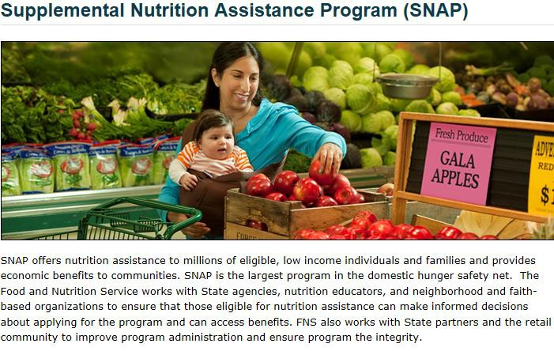

National Programs

National Programs

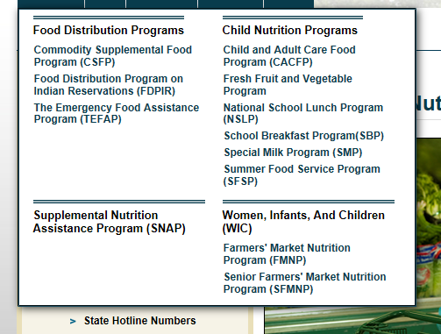

Why Measure Food Environments
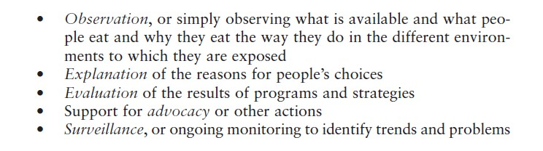
- Per Karen Glanz, PhD, University of Pennsylvania

Food Environment Measures
- Centers for Disease Control are leading efforts to measure health policies effecting food environments in schools, worksites, food stores, restaurants and local/state communities.
- The School Health Policies and Programs Study (assessing vending machines options, fruit/vegetable availability, high-fat foods)
- The School Nutrition Environment State Policy Classification Systems

Food Environment Measures
- What to measure?
  - Types and locations of food stores and restaurants
  - Access to these stores such as hours of operation, drive- throughs
- Measure the consumer environment
  - what exactly is available in stores
  - prices of healthy and non-healthy foods
  - promotion of products
  - children’s food/menu
  - freshness of produce

Surveillance
- Food Environments
  - Macro-level: Environments
  - Micro-level: Individuals

NCCOR
- Once we as nutritionist and public health professionals understand obesity trends, and implement programs, how do we inform policy makers of progress in obesity prevention?
- The National Collaborative on Childhood Obesity Research (NCCOR)



NCCOR
- Common measures and methods across childhood obesity prevention efforts and research
- Measures Registry
  - 750 measures in four domains (individual dietary behavior, individual PA behavior, the food environment and the physical activity environment)
  - Measures included are questionnaires, diaries, logs,
electronic devices and direct observations
- Catalogue of Surveillance Systems
  - 77 surveillance systems providing national, state and local data

NCCOR

http://nccor.org/

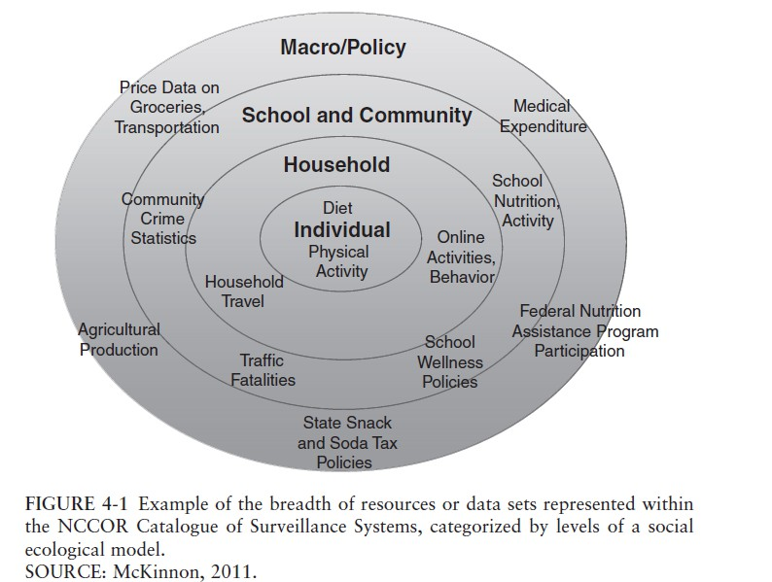
NCCOR


Individual Diet Assessment

- Instruments used to collect the dietary data.
- Food content database used to translate the foods (frequency and amounts) into nutrients.
- Depending on the instrument, you can use different databases.

Food database

- State of the methodology affects actual data.
- Growing conditions of foods & storage variations influences vitamin levels.
- Food preparation influences nutrient content.
- Changing food supply over time.

Specific Instruments: Diet History

- Very detailed.
- 3 components (24hr rcl, food ck, 3-d fd/rec).
- Advantages
  - Produces complete, detailed information
  - Foods consumed by meal


Disadvantages: Diet History

- Cost
- Interviewer training/bias
- Affects eating behavior
- Intakes decrease
- Investigator burden


Food Records
- Respondents records foods and beverages and amounts consumed as they are eaten.
- What is the time period?
- Training of respondent
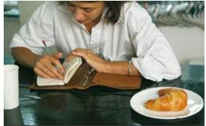
- Review and probing

Food Records
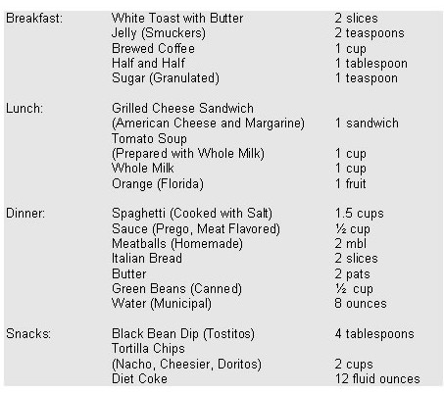


Advantages of Food Records
- Usual intake asked
- Enhance weight control
- Reduction of recall problems: quantity and nutrients: so sometimes the gold standard
- Actual food is obtained

Disadvantages: Food Records

- Cost
- Respondent burden
- Respondent training/motivation
- Interviewer training/bias
- Affects eating behavior
- Intakes decrease

24-hour dietary recalls
- Remember and report all foods for the preceding 24 hours.
- How many days
- By personal interview or by telephone.
- Interviewer knowledge important. Detailed training, re-training and administering
- Structured interview: start with food list and then move to details about what the person ate

Example

Advantages: 24 recall

  - Extremely detailed database used
  - Appropriate for most populations
  - Relatively low respondent burden
  - Actual objective intake
  - Does not affect eating behavior (?)
  - Gold Standard

37

Disadvantages of 24-hr recalls
- Cost
- Many days needed to capture usual intake
- Intake might be underreported
- D/D variability

Food Frequency Questionnaires (FFQ)
- Complete and answer based on a list of foods over a specified period of time: 100 line items
- Information is collected on frequency and portion size
- Very detailed methodology in construction of an FFQ
- Many FFQs developed for different groups: Hawaiian, Japanese, Chinese, Filipino
- Different types/brands
- Analysis of FFQs (ranking)
- Validation against biom./FR’s

Advantages: FFQ
- Usual intake: d/d variability
- Information on total diet
- Low cost
- Does not affect eating behavior

Disadvantages: FFQ
- Difficult cognitive task
- Intake may be misreported
- Not quantifiably precise

Biomarkers
  - Nutrient biomarkers
  - % energy from fat
  - Doubly labeled water for overall energy expenditure

Quality Control
- Respondents
- Interviewers/ Project coordinators
- After completion: reduce noise
- All instruments

Controversy associated with individual assessment

  - Timing of exposure and effect of exposure, so current data may not be linked.
  - Variability of macro/micronutrient intakes should be considered.
  - Recall bias; social desirability
  - Measurement error of the instrument: random error (noise) & systematic error
  - Updated databases & nutrient content

