FACTS
- You can be hungry and obese (source: www.frac.org)
- Low income families are vulnerable to obesity (source: www.frac.org)
- 48% of the Hispanic population are certified CalFresh eligible (source: Ca SNAP Ed plan FFY13)
- Today is Fat Tuesday- It is a day where people eat gluttonous amounts of rich fatty food, drink and 'partake in sin-like behaviors

Maridet Castro Ibanez, R.D.
Administrative Manager II Orange County Health Care Agency
Nutrition Services Program

Dietitian and Public Health Nutritionist who wants to address the nutritional needs of people from womb to tomb

Obesity, Policy and Hispanic
Communities
COURSE OBJECTIVES
  - (6 objectives)
#2. Identify obesity and nutrition interventions through federal nutrition programs and policies

LEARNING GOALS
  - (6 objectives)
#2. Distinguish various nutrition environments and policies in relation to childhood obesity.
#5 Evaluate the role of program and policy interventions in improving food/beverage environment and built environment policies in Hispanic neighborhoods.

Objectives for Today’s
Presentation
Part I
What are the available USDA Food Programs Part II
How one USDA Food Program Addresses Obesity - WIC

CalFRESH
- Left Hand: California Grown Fresh Produce

- Right Hand: California Name for the program formerly known as Food Stamps

SNAP
- Left Hand: Supplemental Nutrition Assistance Program

- Right Hand: A word used to express a feeling of excitement generated during an unexpected or impressive event.

WIC
- Left Hand: Local Furniture Store

- Right Hand: Women, Infant and Children Nutrition Program

CSFP

Left Hand: Commodity Supplemental Food Program

- Right Hand: Catering Services and Food Procurement

Available USDA Food
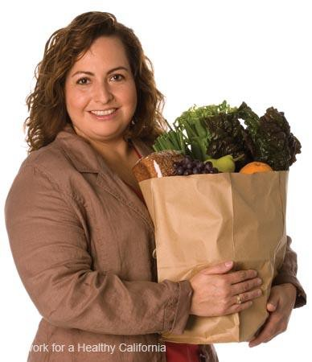
Programs

Part I Objective
Identify all the food programs that income- eligible residents can qualify for:
- People of all ages
- Babies, young children, pregnant and new mothers
- School-age youth
- Older adults

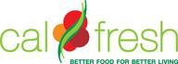
People of All Ages

CalFresh Program
What is CalFresh?
A federally funded program to help low-income people buy the food they need for good health.
- Formerly known as Food Stamps
- Known as the Supplemental Nutrition Assistance Program or SNAP at federal level
- Administered by the Orange County Social Services Agency (SSA)
- Number of OC participants: 226,729 (Nov. 2012)

People of All Ages

CalFresh Program
Who can get CalFresh?
CalFresh is for people and families with low incomes. Anyone can apply.
You may qualify if you:
- Receive CalWORKs or General Relief
- Have limited income or no income
- Have limited property or resources
- Are a U.S. Citizen or a legal resident

People of all ages

CalFresh
What major factors are considered?
- Household Composition: Who resides in the home? Are
they related? Who purchases or prepares food together?
- Income of most individuals who live in the same home that eat meals together is used to determine eligibility: Gross Earnings, Social Security, Unemployment Benefits, Disability Benefits, Workmans’ Comp
- Resources – certain resources may be exempt, and will be explained during the application process.

People of all ages

CalFresh
Who cannot get CalFresh?
  - SSI/SSP recipients – However, your family may be eligible to receive CalFresh benefits.
  - Undocumented immigrants – However, illegal parents may qualify for benefits for their citizen children.
  - Students 18-49 yrs enrolled half time or more in an institution of higher education who do not meet exemption criteria.
  - Drug Felons – Exception: Individuals convicted of a felony for personal use or possession of a controlled substance may be eligible for CalFresh if they meet certain criteria.
  - Fleeing Felons and Probation/Parole Violators


People of all ages

CalFresh
Do I get cash?
- CalFresh benefits are not cash.
- Recipients will be issued an Electronic Benefit Transfer (EBT) card.
- EBT cards are used at checkout like an ATM card or credit card to purchase eligible food items.
- EBT cards can only be used at stores certified as a CalFresh retailers.

People of all ages

CalFresh
How much do I get?
- The amount depends on your income, expenses and
your family size.

Emergency CalFresh
- Households with very limited income & cash resources may receive CalFresh Expedited Services (ES) within 3 days.
- ES services can be applied for online, by phone
application/interview or at the nearest regional office.


People of all ages

CalFresh
What Can I Buy?

Allowed | Not allowed
- Food & Beverages for Human Consumption  - Fruits and Vegetables  - Meat  - Dairy Products  - Packaged, Canned & Frozen Foods  - Snack Food (candy and soda)  - Seeds or Plants to Grow Food | - Hot Food (any food that will be eaten in store)  - Alcoholic Beverages or Tobacco Products  - Vitamins and Medicines  - Pet Food  - Nonfood Items such as: Paper Products, Soap and Cleaning Supplies, Personal Hygiene Products, Grooming Items and Cosmetics, etc.

People of all ages

CalFresh
How do I apply?
- In person at Social Services Admin offices
- In the mail or by fax
- Online at www.benefitscalwin.org
- At Family Resource Centers (FRCs)

Who can I call?
People of all ages

CalFresh

- Regional Center Offices: (714) 541-4895
Aliso Viejo, Anaheim, Garden Grove & Santa Ana
(24 hr. Interactive Voice Response phone number for general info and office locations)

- SSA and CalWORKS Offices
  - Central Regional Office (714) 834-8899
  - North Region (714) 575-2400
  - West Region (714) 503-2200
  - East Region (714) 435-5800
  - South Region (949) 206-4000

People of All Ages

CalFresh Outreach
Unsure about applying for CalFresh?
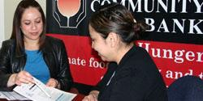
Community partners can help you get more information, get pre-screened or make an appointment.

People of All Ages

CalFresh Outreach
Who do I call?
2-1-1 Orange County
Dial 2-1-1 or (888) 600-4357 (toll free)
Catholic Charities
(714) 347-9601
Community Action Partnership of OC (CAPOC)
(714) 897-6670, x3606
Second Harvest Food Bank
(949) 653-2900, x141

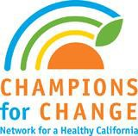
People of All Ages
Network for a Healthy California
How can I use CalFresh to eat healthier?
The Network for a Healthy California works with local partners to provide nutrition education to
CalFresh recipients and those eligible for CalFresh.

What is the Network’s primary goal?
Increase consumption of healthy foods and beverages to help prevent obesity and diet-related chronic diseases, such as diabetes and heart disease.

People of All Ages

Network for a Healthy California
Who provides Network services in OC?
- OC Health Care Agency
  - Local Health Department (LHD)
  - Regional Network
- Schools: OCDE, HBUHSD, NMUSD, SAUSD
- California Assoc. of Food Banks partners:
CAPOC & Second Harvest
- Catholic Charities

People of All Ages

Network for A Healthy California
Local Health Department (LHD)
Provides nutrition education at sites countywide.
Sites include:
CalFresh offices, shelters, low-income housing complexes, community centers, youth sites, health fairs, childcare sites, grocery stores and more
Activities include:
Classes, food demonstrations, displays, peer & staff
trainings, neighborhood assessments, store tours & more.

People of All Ages

Network for A Healthy California
Regional Network (RN) – Orange County Region
- Coordination &Training – promoting the Champions for Change initiative, the NuPAC collaborative & more
- Children’s Power Play! Campaign – for elementary school-age youth
- Latino Campaign – reaching low-income Latinos
- Retail Program – reaching grocery stores & shoppers
- Worksite Program – reaching low-wage earners

People of All Ages

Network for A Healthy California
School Partners
  - Orange County Department of Education (OCDE)
– serving over 15 school districts & ACCESS sites
  - Huntington Beach Union High School District (HBUHSD) – also serving Ocean View, Westminster and parts of Garden Grove school districts
  - Newport-Mesa Unified School District (NMUSD)
  - Santa Ana Unified School District (SAUSD)

People of All Ages

Network for A Healthy California
California Association of Food Banks
  - Community Action Partnership of OC (CAPOC)
  - Second Harvest Food Bank

Catholic Charities
  - Catholic Charities of OC (CCOC)

Babies, young children, pregnant/new mothers

CalFRESH and SNAP Ed
Does it work?
- Each additional SNAP/Food Stamp dollar increases a
household’s score for overall dietary quality (as measured by the USDA’s Healthy Eating Index) (Basiotis et al., 1998).
- Current adult SNAP/Food Stamp participants in Massachusetts living in households participating in the program for at least 6 months have a lower BMI compared to those participating less than 6 months, suggesting that long-term participation is associated with lower BMI (Webb et al., 2008).
- Food insecure adults over 54 years of age participating in SNAP/Food Stamps are less likely to be overweight than non-participants (Kim & Frongillo, 2007).

People of All Ages

T/EFAP
The Emergency Food Assistance Program (TEFAP or EFAP)
Who can get T/EFAP?
Individuals with incomes at or below 150% of the federal poverty level (FPL).
Where is T/EFAP offered?
Offered at over 75 sites throughout the county
Number of OC participants: 63,400 (Est. Dec. 2012)

People of All Ages

T/EFAP
What do I get?
USDA foods including canned veggies, fruits, meats, frozen poultry, juice, rice, beans, pasta and cereal.
May also receive:
  - Fresh produce
  - Bread
  - Snacks such as granola bars or crackers

People of All Ages

T/EFAP
How do I apply for T/EFAP:

Community Action Partnership of OC (CAPOC)
(714) 897-6670

Second Harvest Food Bank
(949) 623-2900

People of All Ages

2-1-1 & Food Banks
Additional food assistance is available through community programs & faith-based organizations
How do I find out about these food sites?
Call 2-1-1
- Call 2-1-1 toll free 24 hours a day, 7 days a week to receive referrals from trained multilingual specialists.
- An initial screening for CalFresh benefits will be conducted. Callers meeting the qualifications will be referred to the CalFresh application process.

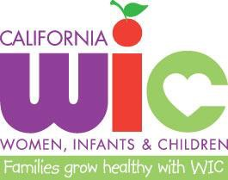
Babies, young children, pregnant/new mothers

WIC
Supplemental Nutrition Program for Women, Infants & Children (WIC)
Who can get WIC?
Pregnant, breastfeeding/postpartum women, infants & children up to age 5 years, with income <185% federal poverty level (FPL). (May also be on CalFresh, cannot be on CSFP)
What do I get?
Nutrition education and checks for supplemental foods specific to needs and age
Number of OC participants: 98,220 (September 2012)

Babies, young children, pregnant/new mothers

WIC
What nutrition education do participants get?
  - Group and individual counseling on a variety of topics specific to the needs of the participant.
  - Online education which can be completed in the home or where they have access to a computer.
  - Breastfeeding education & support. May talk to a Certified Lactation Educator.

Babies, young children, pregnant/new mothers

WIC
What foods can WIC participants receive?
- Fresh fruits & vegetables
- Whole grain breads, tortillas, brown rice & oats
- Milk, cheese, eggs, tofu & soy milk
- Cereals, dry beans or peas & peanut butter
- Infants may receive baby foods & fortified infant formula.

Babies, young children, pregnant/new mothers

WIC
How do I apply for WIC Services?
- Call 888-WIC-Works or 888-942-9675 to find the closest agency.
- Call the local WIC Agency to be prescreened and make an appointment. Proof of ID, address and income will be required for enrollment.
- Applicants can also walk-in to the nearest WIC center and apply for services.

Babies, young children, pregnant/new mothers

WIC
4 WIC agencies serve Orange County:
Camino Health Center
(949) 488-7688
County of Orange Health Care Agency
(888) YOUR WIC
Planned Parenthood of Orange & SB Counties
(714) 973-2411
Public Health Foundation Enterprises (PHFE)
(888) 942-2229

Babies, young children, pregnant/new mothers

WIC
Does it work?
- Young children enrolled in WIC and SNAP/Food Stamps, either or both, have lower rates of nutritional deficiency than low-income non- participants (Lee et al., 2006).
- The overall diets of young children 1 to 4 years of age enrolled in WIC are more nutrient-rich and lower in calories from solid fats and added sugars than the diets of income-eligible non-participants (Cole & Fox, 2008).
- WIC has been shown to prevent overweight and obesity in young children, which researchers predict will reduce obesity-related disease later in life (Bitler & Currie, 2004).
- Data from a recent national study indicate that children participating in WIC are less likely to be obese than income-eligible non- participants (Cole & Fox, 2008).

Babies, young children, pregnant/new mothers

WIC Farmers Market
What else can WIC participants get?
  - The Farmers’ Market Nutrition Program (FMNP) is available to WIC participants one time per year, May 1st through November 30th.
  - Eligible WIC families receive a separate package of vouchers valued at $20 to purchase fresh fruits & vegetables at participating Famers’ Markets.
  - Number of OC participating markets = 15 (2012)

Babies, young children, pregnant/new mothers

CSFP
Commodity Supplemental Food Program (CSFP)
Who can get CSFP?
Pregnant, breastfeeding/postpartum women, infants and children up to age 6 years who are at or below 185% of federal poverty level (& older adults). (May also be on CalFresh, cannot be on WIC)
What do I get?
Food packages containing specific items.
Number of OC participants: 835 women & children (9/12)

Babies, young children, pregnant/new mothers

CSFP
What is in the food package?
Food may include infant formula and cereal, nonfat dry and canned milk, juice, oats, ready-to-eat cereal, rice, pasta, peanut butter, dry beans, canned meat, poultry or fish, and canned fruits and vegetables.
How do I apply for CSFP?
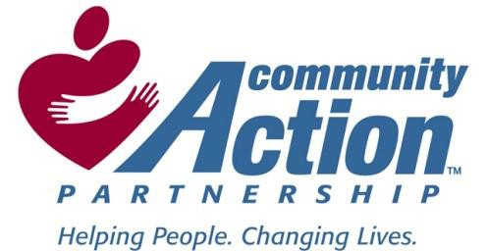
Community Action Partnership of OC (CAPOC)
(714) 897-6670

Babies, young children, pregnant/new mothers &
School-age Youth

CACFP
Child and Adult Care Food Programs (CACFP)
Who can get CACFP?
Children under 18 years and older adults may receive healthy meals and snacks at school & day care sites.
- Head Start
- After school programs
- Childcare sites
- Emergency shelters serving children under 18 yrs.
- Other

Babies, young children, pregnant/new mothers &
School-age Youth

CACFP
What do I get?
Varies by site - Each site determines the foods it offers.
- Meals – up to 3 per day (breakfast, lunch & dinner)
- Snacks
- May use USDA donated foods

Babies, young children, pregnant/new mothers &
School-age Youth

CACFP
How do I apply?
Talk to your daycare or school site:
Head Start of Orange County, Inc.
(714) 241-8920
Children’s Home Society
(714) 456-9800
Other -

Babies, young children, pregnant/new mothers &
School-age Youth

CACFP
Does it work?
- Child and Adult Care Food Program (CACFP) participants 3 to 5 years of age in child-care centers have higher intake of many key nutrients and foods, including vegetables and milk, and fewer servings of fats and sweets (Bruening et al., 1999).
- Children of mothers working non-traditional hours are at greater risk of overweight and obesity, which suggests the importance of providing CACFP afterschool snacks and meals to children, especially those from working families (Miller & Han, 2008).

School-age Youth

School Meals
What is the School Meal Program? Students are provided with lunch & at some sites, breakfast.
- Free Meals: Incomes ≤130% of federal poverty level.
- Reduced Price Meals: Incomes 130 % to 185% FPL.
(Students cannot be charged more than 40¢ for meals.)
- Full Price Meals: Incomes ˃185% FPL
Number of participants: 228,121 (2010-11)

School-age Youth

School Meals
What do students get? New standards in 2012-13
- More Fruits & Vegetables: ½-1 cup fruit and ¾-1 cup of vegetables per day. (Vegetables per week must include dark green, red/orange, beans/peas, starchy or other varieties)
- Meat/Alternative: 8-12 oz. wkly, based on grade level
- More Whole Grains: 8-12 oz. wkly, based on grade level
- Lower Fat Milks: 1 cup per day. Must be fat-free (unflavored or flavored) or 1% low fat (unflavored)

School Age Youth

School Meals
How do I apply?
Contact your local school district for the application form and to learn more about the healthy foods offered at your school

Families receiving CalFresh are eligible for free school meals (by direct certification)

Does it work?
School Age Youth

School Meals

- Low-income school-aged children who eat federally-funded school breakfast have better overall diet quality (as measured by the USDA’s Healthy Eating Index) than those who eat breakfast elsewhere or skip breakfast (Basiotis et al., 1999).
- School meal participants are less likely to consume competitive foods at school, less likely to have nutrient inadequacies, and more likely to consume fruit, vegetables, and milk at breakfast and lunch (Clark & Fox, 2009; Condon et al., 2009; Fox et al., 2009). (Competitive foods are those foods and beverages sold outside of the federally-reimbursed school meals programs, often in a la carte lines, student stores, or vending machines.)

Does it work?
School Age Youth

School Meals

- School-aged children have higher daily intake of fruits, vegetables, milk, and key nutrients like calcium, vitamin A, and folate on days they eat federally-funded supper at an afterschool program compared to days they do not (Plante & Bruening, 2004)
- Participation in federally-funded child care or school meals provided in child care, preschool, school, or summer settings is associated with a significantly lower body mass index among young, low-income children (Kimbro & Rigby, 2010).

School-age Youth
Youth Programs
Over 40% of OC children rely on free and reduced lunches at school. When school is out many of these children may be at risk of going hungry.
Programs serving youth include:
- Summer Meals
- Kids Café
- Backpack Program


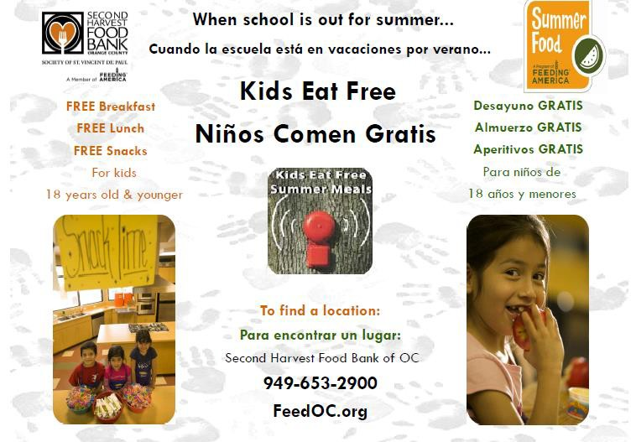
School-age Youth

Summer Meals
How do I apply?
Select community and school sites offer Summer Meals. Anyone under 18 years of age can walk into any of these sites and receive food. No application is required. Contact the site for the summer breakfast & lunch meal hours.
For locations, call 2-1-1 or visit the Second Harvest website:
www.feedoc.org
and click on the Summer Meal link

School-age Youth

Kids Café & Backpack Program
How do I apply?
- Kids Café – is an after school snack program. Any child under 18 yrs can visit a Kids Café site & receive a snack during snack time. There are currently 39 sites located throughout OC.
- Backpack Program – is a weekend and school vacation meal program. Backpacks containing food are distributed to children in 7 facilities located in low income communities.

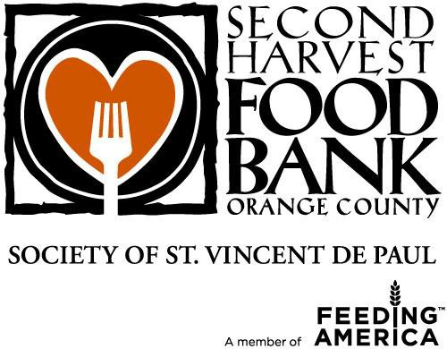
Contact Second Harvest to find participating sites – www.feedoc.org or (949) 653-2900

School Age Youth

Youth Programs
Does it work?
  - Children are more vulnerable to rapid BMI gains and food insecurity during the summer – a time when many do not have access to the good nutrition provided by the school meal programs (Nord & Romig, 2006; von Hippel, 2007).

Older Adults

CSFP
Commodity Supplemental Food Program (CSFP)
Who can get CSFP?
Adults who are at least 60 years of age and at or below 130% of federal poverty level (& perinatal women & children <6 yrs).
What do I get?
Food packages containing specific items.
Number of OC participants: 23,920 older adults (9/12)

Older Adults

CSFP
What is in the food package?
Food may include nonfat dry and canned fluid milk, juice, farina, oats, ready-to-eat cereal, rice, pasta, peanut butter, dry beans, canned meat or poultry or fish, and canned fruits & vegetables.
How do I apply for CSFP?
Community Action Partnership of OC (CAPOC)
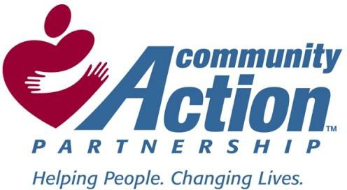
(714) 897-6670

Older Adults

Brown Bag
Who can get Brown Bag?
Older adults over 60 yrs of age with income < ?? talk to Bob
What do I get?
Two bags of groceries are distributed every two weeks. Items may include canned goods, produce, dried beans, rice, cereals and more.
How do I apply
Contact Second Harvest for a list of the 37 participating sites: www.feedoc.org or (949) 653-2900
Number of OC participants: 3,900 (September 2012)

Older Adults

Senior Farmers Market
The Senior Farmers’ Market Nutrition Program (SFMNP) is available during the summer to help older adults purchase fresh produce.
Eligible seniors receive a package of vouchers valued at $20, from 1 of 4 agencies serving older adults, to purchase fresh fruits and vegetables at participating Famers’ Markets.
Number of packets distributed: 1,750 (2011)

Older Adults

CACFP
Child and Adult Care Food Program (CACFP)
Who can get CACFP?
Older adults may receive healthy meals and snacks at adult day care sites.
How to apply?
Talk to local senior center or contact:
Orange County Office on Aging
(800) 510-2020
(714) 567-7500 if on cell phone or outside OC

People of All Ages

2-1-1 & Food Banks
Additional food assistance is available through community programs & faith-based organizations
How do I find out about these food sites?
Call 2-1-1
- Call 2-1-1 toll free 24 hours a day, 7 days a week to receive referrals from trained multilingual specialists.
- An initial screening for CalFresh benefits will be conducted. Callers meeting the qualifications will be referred to the CalFresh application process.

USDA FOOD PROGRAMS
Common Threads
- Addresses food security of at risk populations
- Creates food availability: Brings food into the neighborhoods (grocery stores that accept food assistance, farmers markets)
- Creates food affordability: minimizes fast food, minimizes inflated food prices
- Raises the economy of a local neighborhood

USDA FOOD PROGRAMS
Common Threads
- Addresses food security of at risk populations
- Brings food into the neighborhoods (grocery stores that accept food assistance, farmers markets
- After years of criticism that food programs contributed to obesity:
  - Core messages
    - Drink low or non fat milk or dairy
    - Eat Fruits and Vegetables
    - Eat Whole Grains
    - Avoid sugar sweetened beverages
  - Backed up food items that support the message

Part II Objective

The WIC experience - How one USDA food program addresses childhood obesity
  - Team up by two
  - Identify yourself as pregnant, breastfeeding, mother of an infant, mother of a child – Make up a name
  - Answer the questionnaire

WELCOME TO WIC
    - http://www.youtube.com/watch?
v=xI9ZEnX7tTk

What Do You Get at WIC?
Nutrition Education Individual Group
Access to Food
Referrals
Breastfeeding Support and Promotion

The WIC Experience
Group Education
Class of the Month – variety of topics Shopping with your WIC checks –
http://www.youtube.com/watch? v=vdzGiIFwRgA

The WIC Experience
Individual Education
Assess eligibility: proof residence, proof of income, presence at certification

Assess nutritional risk: Medical Information, nutrition questionnaire

The WIC Experience
How do the assessment tools identify obesity or at risk for obesity?
Medical Form: Anthropometric (BMI), Biochemical (anemia), Clinical (acute/chronic disease)

Nutrition Questionnaire: Dietary Risks
Kinds of foods served or consumed Amounts of foods served or consumed Food Habits/Preference (cultural influence)
Feeding Environment – who prepares, food security Physical Activity

The WIC Experience

Counseling Session

The WIC Experience

Going to buy WIC foods

The WIC Experience

The Return Visit

Did We Meet Today’s Objectives?
COURSE OBJECTIVE:
Identify obesity and nutrition interventions through federal nutrition programs and policies
- USDA food programs available
- Identified reasons why the food programs work in addressing obesity
  - Food Items available were nutrient appropriate
  - Backed up nutrition education “teaching folks to eat healthy”

Did We Meet Today’s Objectives?
LEARNING GOALS
#2. Distinguish various nutrition environments and policies in relation to childhood obesity.
- USDA programs and their policies – food access + education
- WIC Experience – assessment, education and influencing food purchase behaviors = healthy choices and obesity prevention

Did We Meet Today’s Objectives?
LEARNING GOALS
#5 Evaluate the role of program and policy interventions in improving food/beverage environment and built environment policies in Hispanic neighborhoods.
- Changing individual behaviors to drive the demand for environmental changes
– The WIC Experience

Did We Meet Today’s Objectives?

Thank you and
Mission Accomplished

