
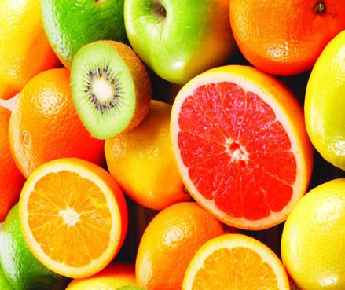


NUTRITION
PATHWAYS
Nutrition is central to health promotion and disease prevention as it enhances the delivery of many services, including dietetics, public health nutritionists, dentists, nurses, physicians, and others. In this brochure, you will find key information on various
educational routes in nutrition-related fields.
Careers in nutrition and other health-related fields
Careers in nutrition are available in a wide variety of settings including public health, education, food service management, research, policy, facility design, to name a few. In addition, below is a list of top careers that utilize nutrition expertise according to the US News and World Report list of 2013:

- Dentist
- Registered Nurse
- Pharmacist
- Computer Systems Analyst
- Physician
- Database administer
- Physical Therapist
- Occupational Therapist
- School Psychologist

Please refer to http://www.healthcareers.com/eatright for more information on health-related and nutrition careers.

The United States Department of Agriculture (USDA)
The USDA is a department within the US Federal government, responsible for developing and executing policy on forestry, food, agriculture, and farming. A wide range of careers are suitable in various departments within the USDA, such as:

- Biologists
- Nutritionists
- Forestry Technicians
- Research Agricultural Engineers
- Food Inspectors
- Soil Scientists
- Program Specialists
- And many more…

Please refer to http://www.usda.gov/wps/portal/usda/usdahome for more careers options.

Contact Information
Dr. Archana McEligot amceligot@fullerton.edu

Alysia Ransons aransons@fullerton.edu
For further Nutrition career resources, visit…
Centers for Disease Control and Prevention http://www.cdc.gov/nutrition/

The Academy of Nutrition and Dietetics http://www.eatright.org/

American Society for Nutrition http://www.nutrition.org/education- and-professional- development/graduate-program- directory/

To view further info on this brochure and other programs, visit…

Comidas y Comunidades Saludables http://ccs.fullerton.edu/index.htm

Registered Dietitian

A Registered Dietitian (RD) is a food and nutrition expert who has met the minimum academic and professional requirements for the credential.

Where do the majority of RDs work?
Many work in the treatment and prevention of disease, in hospitals, HMOs, academia and research, food and nutrition industries, sports nutrition, community and public health settings, private practice or other health-care facilities.

What is needed to enter an RD program?
- Complete a minimum of a bachelor’s degree at a U.S. regionally accredited university, college, or foreign equivalent.
** similar to applying to medical school or other allied health fields, to apply to a RD program, you should obtain a BA or BS and also complete required courses in chemistry, biology, nutrition, and/or organic chemistry, etc. Please review the specific guidelines for the respective program you are interested in applying.
What is expected once you are in a RD program?
- Complete coursework through Accreditation Council for Education in Nutrition and Dietetics (ACEND), accredited Didactic Program in Dietetics (DPD), or Coordinated Program in Dietetics (CP).
- Complete 1200 hours of supervised practice through an ACEND accredited Dietetic Internship or Coordinated Program in Dietetics.

- Pass a national examination administered by the Commission on Dietetic Registration (CDR). In order to maintain credential, an RD must complete continuing professional education requirements.

Sources: http://www.eatright.org/BecomeanRDorDTR/

Public Health Nutritionist
A Public Health (PH) Nutritionist promotes health and reduces the risk of chronic diseases through nutrition, education, and program development in a community, research, and/or population-based setting.

Where do the majority of PH Nutritionist work? Public Health Nutritionists work in school food services, community kitchens, food product development, agriculture, food systems analysis, and health agencies to name a few.

What is needed to become a PH Nutritionist?
- Complete a minimum of a bachelor’s degree at a U.S. regionally accredited university, college, or foreign equivalent.
- Recommended is the completion of a Masters in Public Health (MPH), Nutrition, and/or Public Health Nutrition coursework.
- Depending on you specific program requirements, the completion of a public health internship, this serves as the culminating experience of your program.

What if I already have a degree?
If you already have a bachelor’s degree and are interested in the public health field, a college transcript should be evaluated by an advisor who will identify the courses needed to fulfill program requirements.

Please visit http:www.petersons.com/graduate- schools.aspx to identify graduate and public health programs, as well as, application, examinations, and other requirements and tools for preparation.
Sources: http://www.cdc.gov/nutrition/
http://giph.nyu.edu/mph/academics/concentrations/public-health- nutrition.htm http://nutrition.hhd.psu.edu/undergraduate/Emphasis-Careers

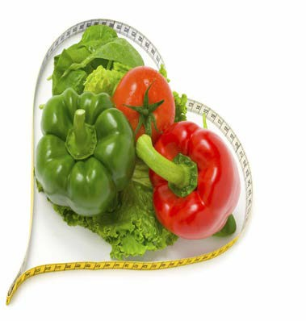

Graduate Programs in Nutrition
Obtaining a Masters and/or a PhD in Nutrition entails a more focused study. The American Society for Nutrition highlights various graduate programs in Nutrition in California:

- California State University, Chico
- California State University, Long Beach
- California State University, Northridge
- California Polytechnic State University
- Loma Linda University: School of Public Health
- Pepperdine University
- San Diego State University
- San Jose State University
- University of California at Berkeley: Graduate Program in Nutrition
- University of California Berkeley: Public Health Nutrition
- University of California, Davis
- San Francisco State University
- Chapman University

For more information, please visit http://www.nutrition.org/education-and-professional- development/graduate-program-directory/

